DLSS - Perf/Visual Evaluation
Deep Learning Super Sampling (DLSS) was assessed for its visual and performance impact on a GFN 2080 (target hardware device) during the scenarios listed below.

DLSS is an upscale/AA solution that replaces and/or works with UE’s temporalAA/upscaler (depending on the rendering feature). DLSS relies on operating at a lower screen percentage and upscales the shot to your desired maximum resolution. The recommended starting point is 66.7% however due to the 2080’s lower power this was assessed and tested at 50%.

Test Scenario: DLSS was toggled on/off to assess visual impact and performance impact at 50% screen percentage:

Visual Comparisons
The visual impact is quite subtle in most cases. When analyzed its best to compare the impact of thin geo (like small tree roots) and Tooka hair. The image seems slightly less noisy with DLSS but because our DOF is so aggressive it is difficult to discern if the image quality is necessarily “better” with DLSS on vs off. IMPORTANT: Still images make assessing AA/Upsampling very difficult. The video comparison or testing first-hand are better analysis of the below.

Visual Comparison Folder

Comparison Videos

DLSSComparisons_wCommentary.mp4

tooka_5sDLSSoff_5sDLSSon.mkv

Top = DLSS Off / Bottom = DLSS On

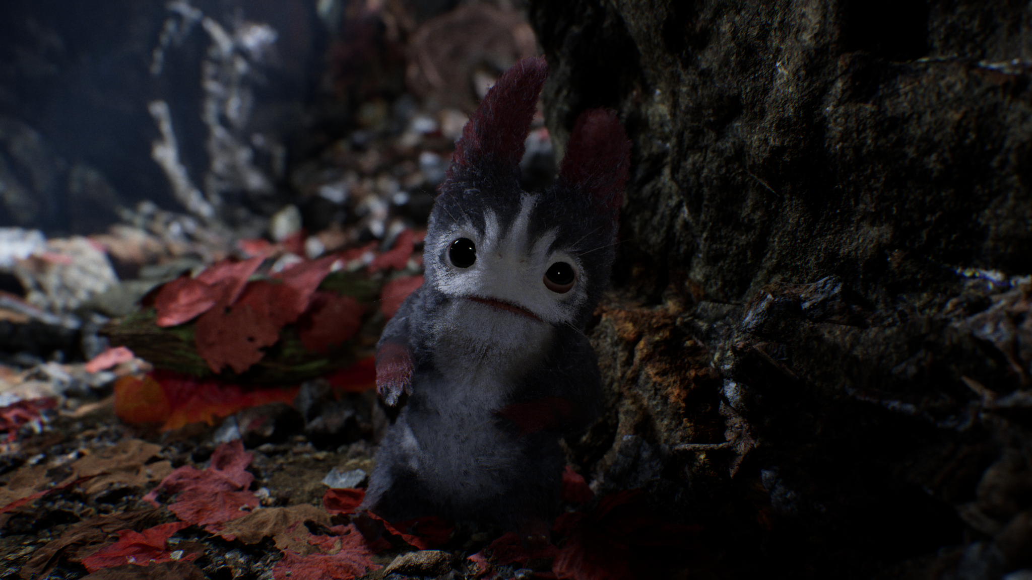



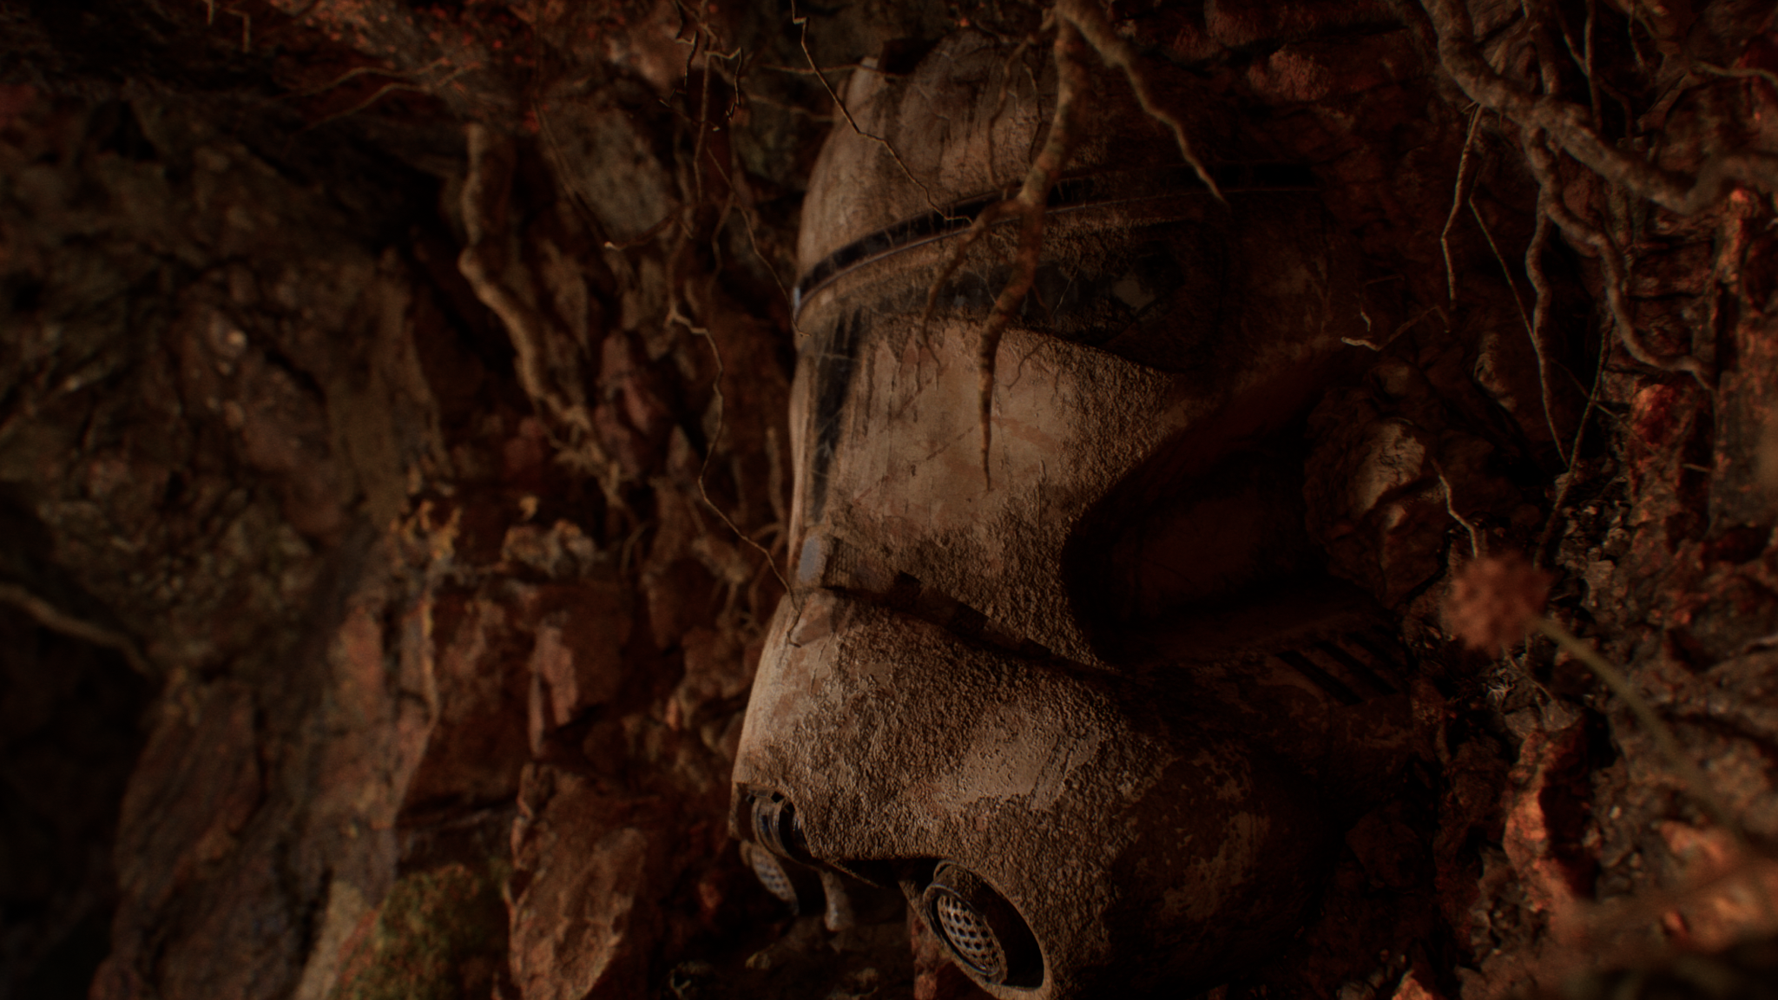
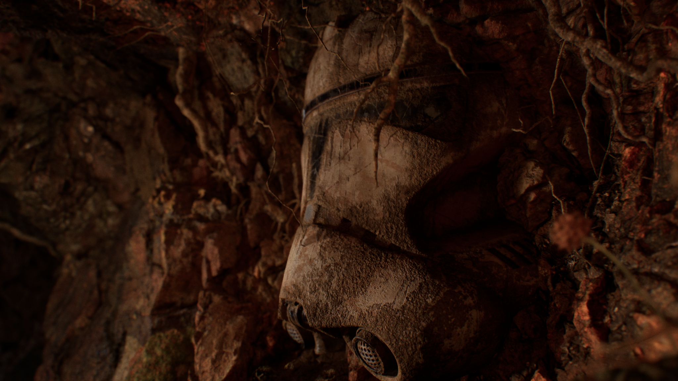

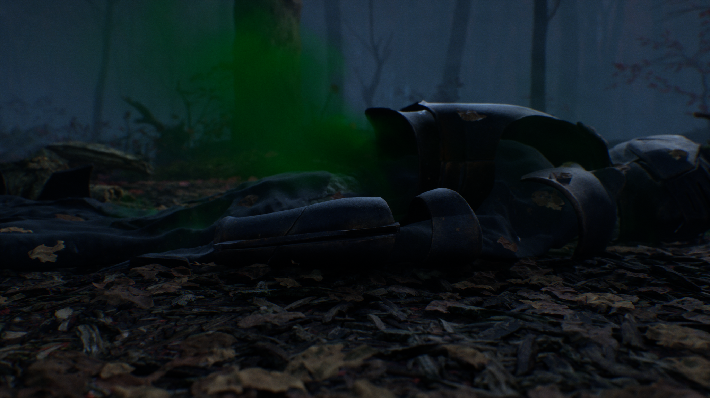
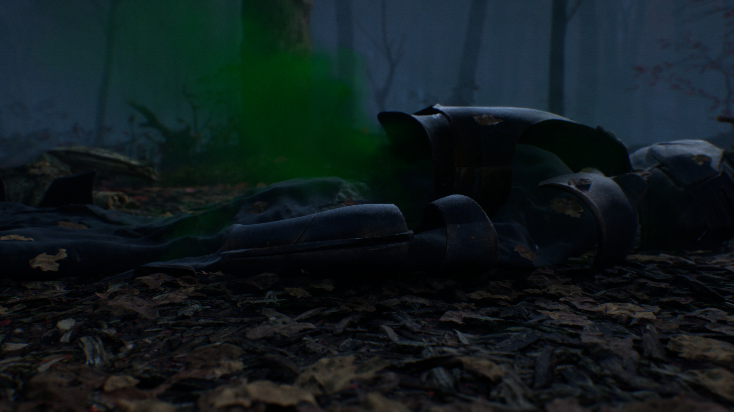

Data
Scenario | GPU Cost
2080 DLSS off | 0.60ms - 0.8ms
2080 DLSS on | 0.60ms - 0.8ms

Assessment
DLSS is more or less a breakeven performance wise with our standard temporal superresolution AA/upscaler within +/- 0.25ms in most cases. The main decision point remains if art direction believes it is a visual improvement. It also appears to take a few frames to adjust to the best possible look. (Guessing this is the “deep learning” part of DLSS).

DLSS’ “performance improvements” come from using a static lower screen percentages not from anything special that DLSS is doing, it just replaces temporal super res (and costs roughly the same). We would still want to use dynamic res to cover for heavy moments on both platforms. Static screen percentage was our original course of action we moved away from.

Dynamic Resolution Factor
DLSS does work with dynamic resolution, so we would maintain better resolution in lighter performance moments as we have.

2080 Considerations
The 2080 has some lower settings for lumen and general screen resolution (though dynamic res allows it to be as high as it can possibly be frame-to-frame) which appears to have some difference between general screen noise levels compared to the 3080.

DLSS appears to drastically improve this on 2080 configurations.

Official Recommendation
This late in the project (at the time of writing the project was near alpha/content lock) is typically ill-advised BUT since there are visual issues with hair + noise, especially on the 2080 this may reduce scope for render engineers and provide an overall image clarity/denoising.

This is purely an art direction decision based on the visual eval. We will not gain or lose performance from using this feature.

