ILMxLAB UE5 Research - Nanite
Contributors: Matt Canei

Introduction
Nanite is a new geometry rendering system introduced in UE5 that converts static meshes to special render passes that streams geometric detail in-or-out based on camera proximity. Nanite data is highly compressed and automatically handles all transitions and replaces the need for manual LOD setups when it is used.

Nanite is particularly designed for environments/scene assembly and does not have any practical applications for characters, animation or VFX (yet). The research below shows a wide range of triangle-to-performance ratios. In all cases and hardware scenarios, Nanite offered a significant boost in triangles (75x-1000x depending on use case and hardware). This ratio should always be measured/established per-platform.

Official Documentation on Nanite

Does Support
- Standard Static Mesh Placement
- In-Engine Features:
  - Foliage/ISM/HISM
  - Geometry Collection
  - Vertex Colors
  - Simple dynamic transforms (non-deforming)
  - Multiple UV sets
  - Multiple Material IDs
    - Cannot Nanite/Not Nanite by ID.
  - LODs
    - Only used to aid in complex collision and proxy mesh generation.

Does Not Support
- GPUs below Nvidia Maxwell (900 Series) and AMD GCN (Radeon HD 7000)
- VR (Stereoscopic rendering)
- Forward Rendering
- In-Engine Features:
  - Skeletal animation
  - Morph targets
  - WPO/Displacement in materials
  - Spline meshes
  - Custom depth/stencil
  - Per-instance vertex colors
  - MSAA
  - Lighting Channels
  - Raytracing against full Nanite mesh
  - Material Features:
    - Any non-opaque blend modes (including Masked)
    - Decals
    - Pixel Depth Offset
    - World Position Offset (Vertex Shader)
    - Custom Per-Instance Data
    - Two Sided

Best Practices
- Meshes intended for Nanite should still be cleaned up/tri reduced until the point they start to degrade.
  - Wasted triangles, even with Nanite’s help, still wastes memory/disk space/performance. (See Case Study #1 for rationale).
- Since clusters are generated in 128 triangle increments, meshes with large spans between triangles (like a long elevator shaft) will have huge clusters, adding edge loops across some large planar spans (floors/long walls) may be necessary to accommodate Nanite's cluster generation.
- Custom proxy meshes may be imported via Import LOD + Minimum LOD set to that LOD level. That allows full control over the proxy mesh (important for projects with light baking).
- Do not use Generate Lightmap UVs unless a project uses static baked lighting on Nanite meshes.
- Avoid thin geometry (cases where you might ordinarily use two-sided materials or the geo only has a thin lip of geo between sides). Nanite clusters can z-fight through the backs at distance causing visual artifacts.
  - See Case Study #3 Images
- Avoid high-frequency patterns (such as ridges on TIE fighter wings). They can cause banding, aliasing artifacts and other visual issues when used in Nanite.
  - See Case Study #3 Images
- When re-using the same mesh in Nanite hundreds or thousands of times, convert those instances to HISM components when transforms are final for free performance on the CPU (and slight GPU improvement).

Suggested Uses
- Set pieces that can be batched/instanced containing/requiring high level of detail
  - Large rocks/cliffs
  - Trims/frames (separate from wall pieces that would stay lower tri counts)
  - Modular sets requiring high levels of detail (greebly walls)
- Hero pieces
  - High detailed single/or low use pieces that are story focal points or otherwise need to be large tri counts that do not need any vertex shading/deformation.

Impractical Uses
- Unique set pieces that are not hero and are not instanced heavily.
- Organic matter
  - Plants, grass, leaves (non-WPO geo grass may be exception)
    - Trunks excluded
    - Single layer like ivy/vines may work in some circumstances.
- Set pieces that can hit quality without high tri counts
- Meshes with separate layering, thin surfaces or holes
  - Set pieces with physical space/holes (such as a grate).
  - Leaves or forest canopies in a tree (fully modeled out).
- Overlapping ground scatter
  - Similar to above, any stacking/layering/overlapping of nanite meshes can cause performance issues.

Gotchas
- File I/O bound, since geometry is streaming in and out.
  - SSD hardware may be an outright requirement for Nanite to work.
  - See Case Study #2 - Hardware Configuration #2 results for more.
- Disk size
  - Nanite does compress mesh, but may not be ideal in all cases.
- Nanite instances are capped at 2 million when used within ISM/HISM.
- Lightmass baking, raytracing, per-poly collision all use the proxy mesh, not nanite mesh.
- Nanite occlusion/culling is its own pass, that is subject to performance degradation as a result of nanite overdraw. Stacking/layering would appear to follow similar rules to translucency overdraw.
- Screen percentage does impact Nanite transitions and performance. Larger resolutions keep more detail longer. 1080p vs. 2160p appears to be a near linear 2x performance cost as well as a direct multiplier of screen primitives.

Technical Description (“How it works”)
Full technical explanation: http://advances.realtimerendering.com/s2021/Karis_Nanite_SIGGRAPH_Advances_2021_final.pdf

Import Time
- Geometry is divided into clusters by groups of N (usually 128) triangles.
  - Cluster groups have their own bounds for occlusion/culling/depth at runtime.
- Clusters are grouped to clean shared boundaries.
- Clusters are simplified by 50% of triangles.
- Split out that list of clusters and rinse-repeat with a new 50% drop each time. (LOD generation).

Runtime Render Pipeline
- Two-pass Occlusion/Depth (Called CullRasterize)
  - Takes depth (HZB) from the previous frame to do basic frustum culling, LOD cluster swaps and occluded clusters.
  - Build new depth/HZB buffer, run 2nd pass to cleanup/render now visible regions.
  - Rasterize the end result.
    - Hardware rasterization pass (large triangles)
    - Software rasterization pass (small triangles)
  - Visibility Buffer
    - Packed scene texture that contains important rendering information:
      - Triangle ID, Cluster ID, Depth
- EmitDepthTargets
  - Takes information from last pass and assembles the following outputs:
    - Nanite motion vectors
    - Scene depth
    - Nanite mask (Mask of nanite meshes vs. non-nanite meshes)
    - Material mask
      - One of the major victories of Nanite is deferred materials. In nanite, material rendering is decoupled from all rendering passes, and instead assigned via a screen/scene texture by grayscale value and only iterated over once per material, instead of per-instance, per-material.
- Base Pass + Nanite BasePass (appears to happen in parallel)
  - ClassifyMaterials
    - Takes material mask and runs a fullscreen compute shader to create a fullscreen material ID assignment “texture’.
  - EmitGBuffer
    - VisibilityBuffer is compared to the end result of ClassifyMaterials to render a draw call for each material ID PER FRAME (instead of per-mesh).
    - Rendering of the GBuffer
- Non-Nanite GPU passes occur: light grid, skyatmosphere, volumetricfog, post etc.

Case Studies

Case Study #1: Foliage AB Test

Introduction
This case study seeks to answer the following questions:
- How does Nanite work with Instanced Foliage (HISM)?
  - Short Answer: Same as just using a Static Mesh with that system with Nanite set to true.
- How does Nanite used in foliage compare with traditional asset tri counts for the same mesh/instance count?
  - Short Answer: Nanite performed about 2x better at ~200x triangle density in the source meshes. Nanite’s tri count-to-performance ratio will differ by hardware.

Open landscape painted with ~200 million triangles worth of rocks (996k tris per rock). Rocks toggled between base setup (no LODs) (Scenario A), with 2 lower LOD’s (Scenario B), Nanite meshes (Scenario C), and practical setup with 2 lower LOD’s with the base mesh at a typical real-time tri count (15k) (Scenario D). The foliage tool in UE5 renders all instances as a hierarchical instanced static mesh (every instance is batched and does not occupy a draw call but can individually LOD and cull).

Hardware: Local PC, 3090 RTX (GPU) & Intel Core i9-10980XE (CPU, 36 threads)

Scenario A (Base Setup [no LODs])
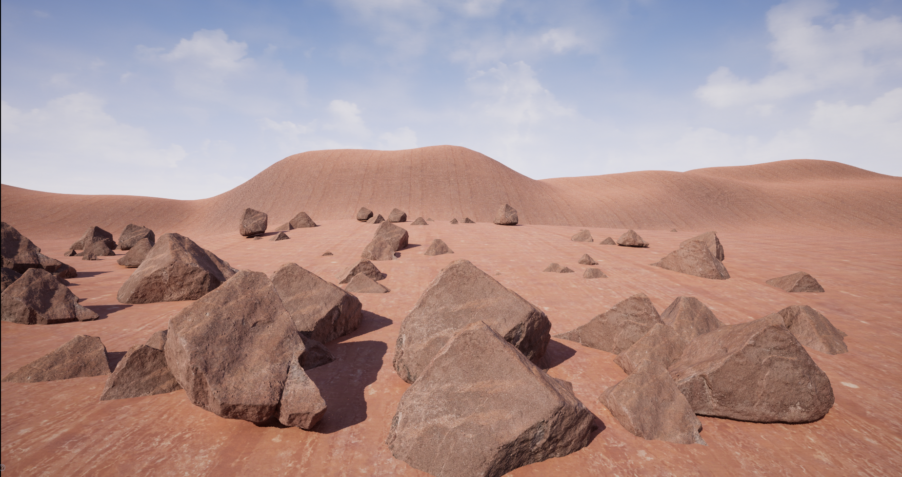
200 million triangles, no LODs, 996k tris per rock

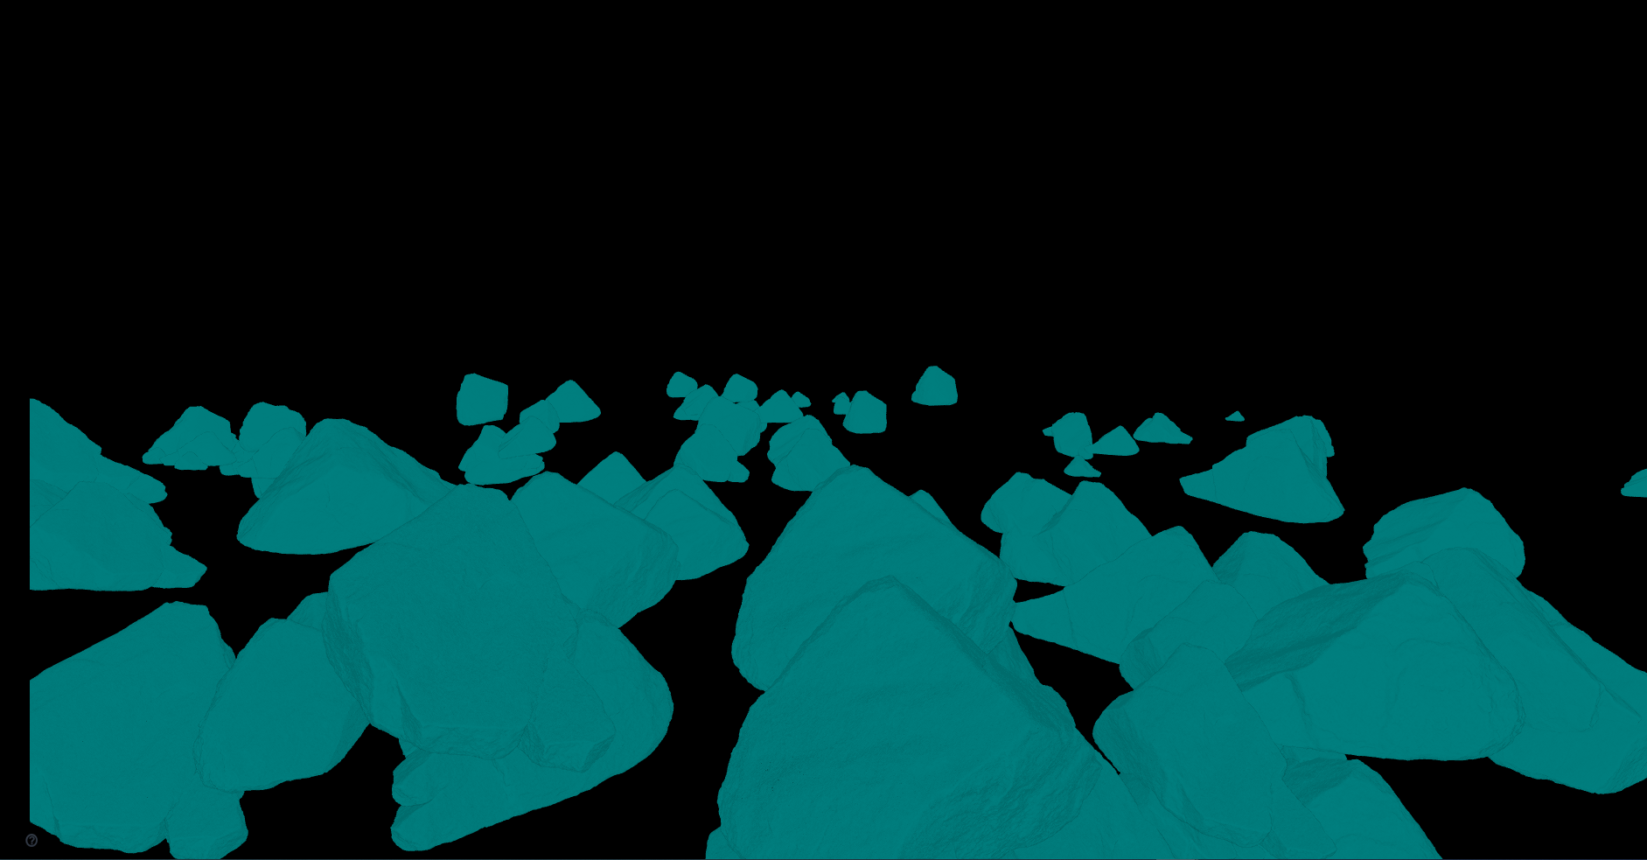
Wireframe view (mesh is too dense to see geometry)

Scenario B (Classic Setup [3 LODs])
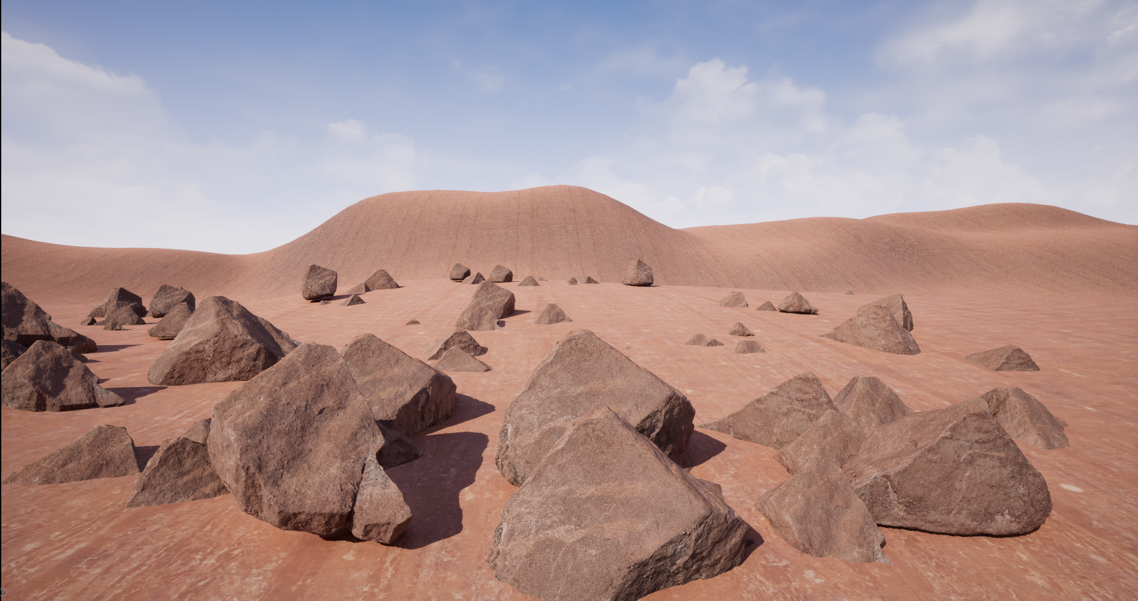
80.7 million triangles, 3 LODs (50% drop per LOD)
Wireframe view (mesh is too dense to see geometry)

Scenario C (Nanite)
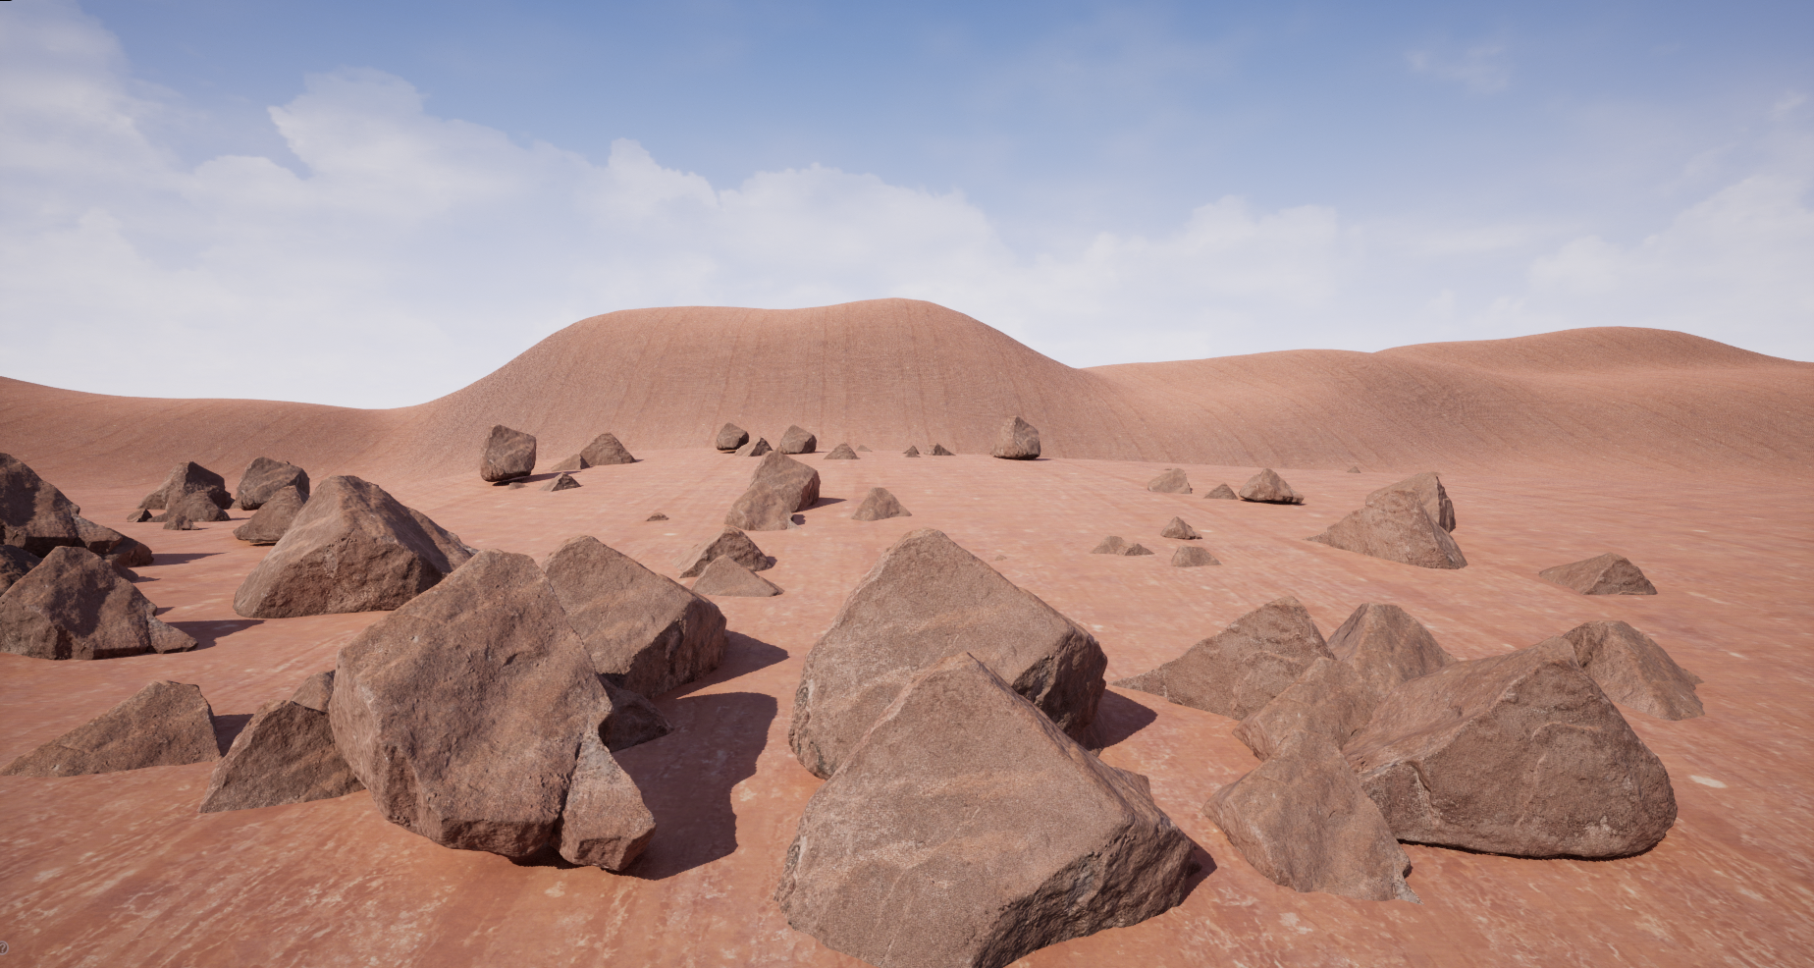
Nanite triangles, triangles streamed in/out based on distance.

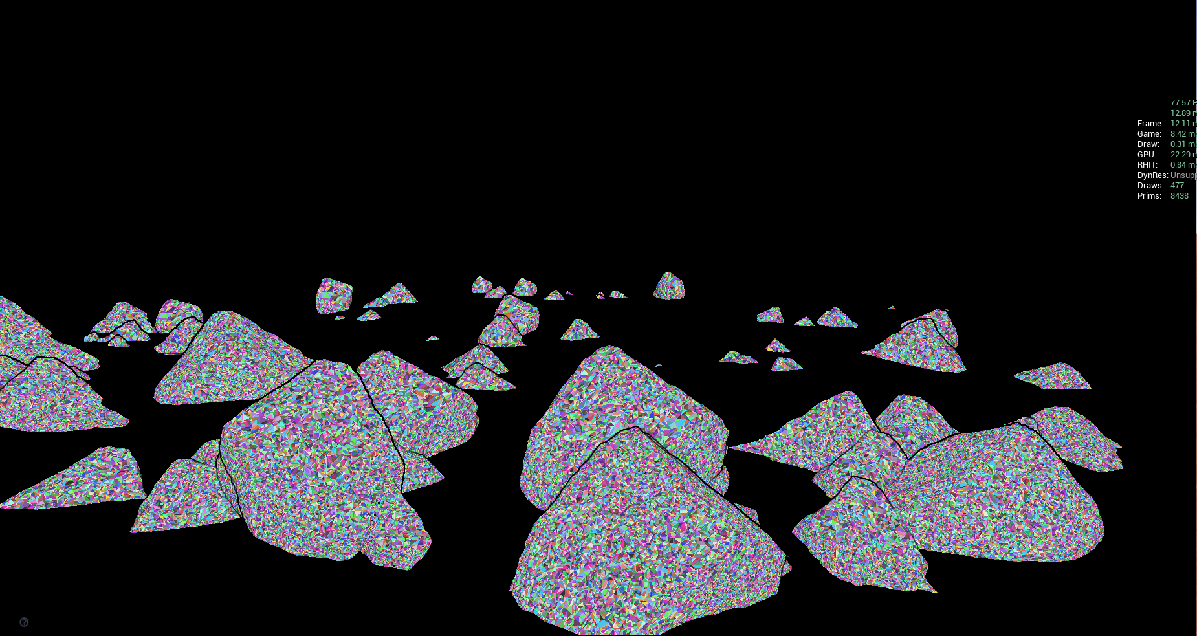
Nanite’s triangle viewer, take note of the higher density of triangles for rocks closer to the camera.

Scenario D (Practical Setup [3 LODs], 15k tri base mesh)
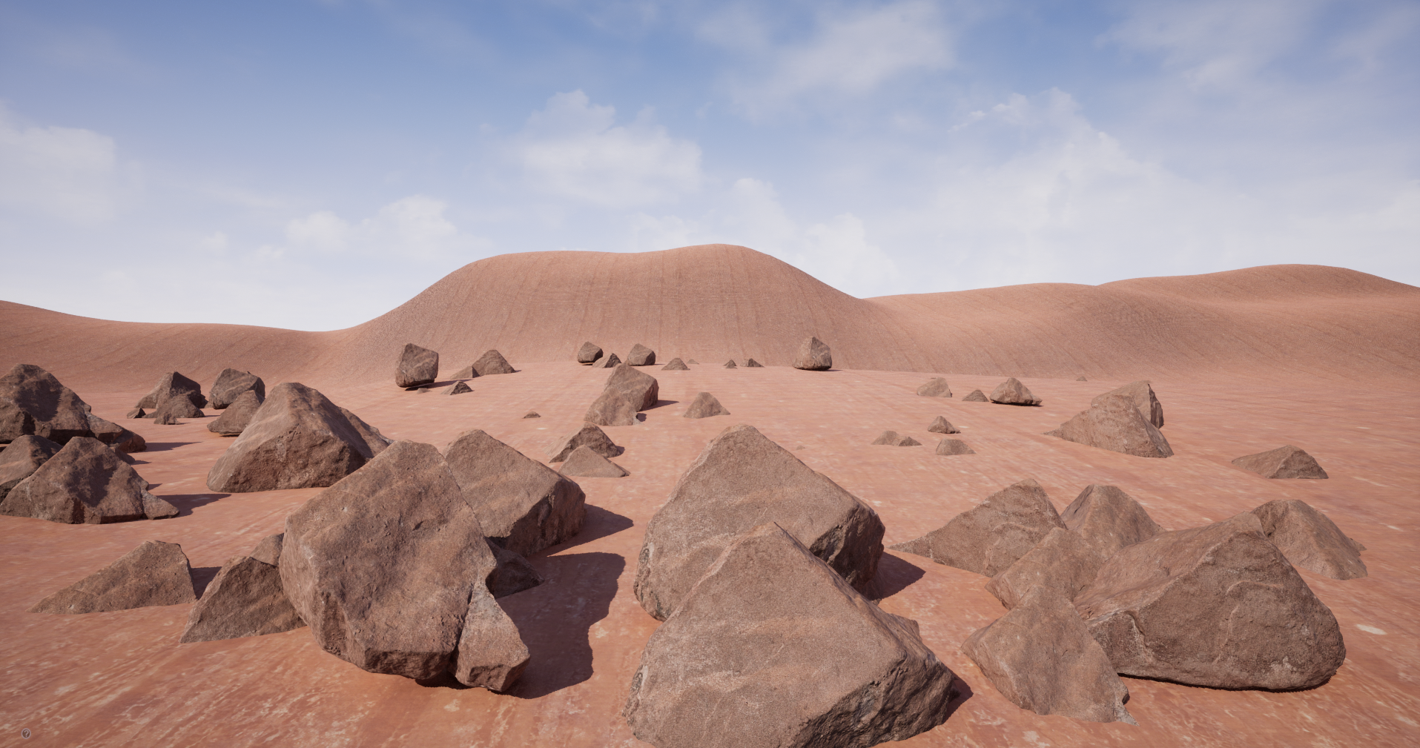
Practical setup, 3 LOD’s starting at 15k tris each.

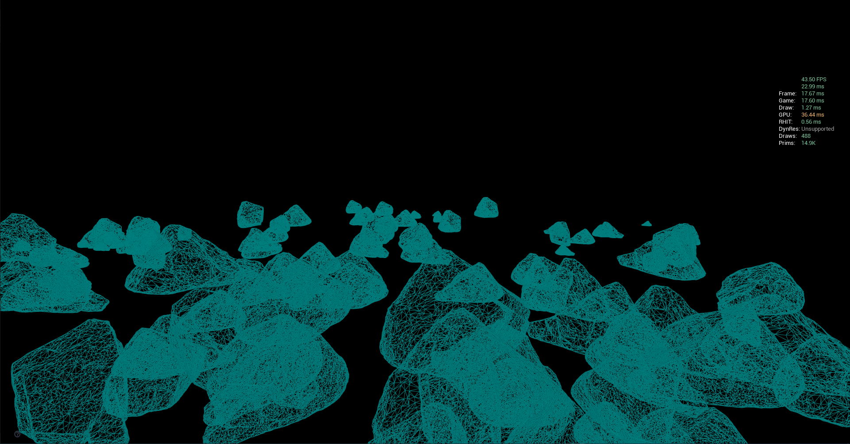
Wireframe

Performance
Scenario | FPS | Frame Time | Game Thread | Render Thread | GPU | Tri Count | Asset Size Map
Base | 16 | 61.65ms | 13.20ms | .60ms | 61.65ms | 197m | 120.9mb
LODs | 32 | 30.98ms | 12.50ms | .10ms | 30.98ms | 80.7m | 166mb
Nanite | 93 | 10.97ms | 7.40ms | .52ms | 10.97ms | 46k | 76.4mb
Practical | 57 | 17.64ms | 16.60ms | .15ms | 17.64ms | 1.39m | 3.5mb

Assessment
Overall, the Nanite scenario appeared far superior in this particular use case for runtime performance. The major takeaway is that the disk size of the base mesh is still charged to the footprint of the project, so in a scenario where an entire project was at film quality, the disk size/memory/project footprint could get unsustainably large, even with Nanite compression.

If a project has tight memory constraints and/or slower storage, the practical scenario has the lowest memory/disk size footprint and still strong performance. However, if the UE5 foliage system is used to maximize instancing/re-use, use cases such as large boulders/rocks - Nanite’s run-time behavior is far superior. We must exercise caution around Nanite’s weaknesses.

In Scenario A (Base Scenario, no LODs) a few important observations were made. First, the HISM/Instanced Foliage system seems to have a hard limit of 200m tris before the meshes stop rendering or have some sort of culling artifacts. Reusable scatter/ground cover such as rocks would never be allowable at 996k tris for LOD0 in almost all real-time projects, so Scenario A is not a practical scenario, but it was shown to demonstrate performance differences.

In Scenario B, it's clear that the classic LOD workflow is effective in improving performance, but the source mesh is so heavy at 996k tris that even a LOD setup is impractical for achieving a performant scene.

In Scenario C, Nanite demonstrates its full magic by taking a 200m tri scene and improving performance by nearly 6x. There did not appear to be quality loss or any visual change whatsoever.

In Scenario D, this is the same scenario as B but the tri counts were adjusted to 15k/7.5k/3.75k to better represent practical use of rock placement how real-time projects typically would pre-Nanite. This method would still be preferred for projects/hardware/constraints that cannot properly handle Nanite.

Questions/Follow Up Tests
- How would a slower hard drive and/or RAM/VRAM impact stat unit times for the above scenarios? Would the proportions between each change? Would there be different clear cut “winners”?

Case Study #2: Modular Architecture AB Test

Introduction
This case study seeks to answer the following questions:
- How does Nanite work with modular meshes?
  - Short Answer: Works great, as long as best practices are applied.
- How does that compare to the same meshes in a traditional sense (lower/typical current gen tri counts)?
  - Short Answer: On great hardware, nanite meshes performed within 15% performance at 1000x density.
- How does Nanite perform in baked vs. dynamic lighting?
  - Short Answer: Dynamic lighting was ~1.44x more expensive for Nanite AND traditional.
- How does Nanite perform on Non-SSD hardware?
  - Short Answer: Needs more device testing, but it appeared 5-10% worse than SSD.
- How does Nanite compare to regular content in terms of Disk Size and Memory?
  - Short Answer: Depends, it is far higher than traditional content (~10x) but when compressed it is much smaller than the same source content with Nanite disabled.

A small interior scene of a hallway into an open room using all modular architecture from Quixel Bridge (MegaScans). The same room was created with Nanite-detailed meshes (high tri counts) (Scenario A - Nanite) vs. Medium quality (more real-time/VR ready tri counts and 2k textures) (Scenario B - Traditional). As a demonstration of Nanite’s performance power, Scenario C numbers are added to show Scenario A’s set pieces with Nanite disabled.

The above scenarios will be recorded against multiple hardware configurations, fully dynamic lighting vs. static baked and against screen percentage.

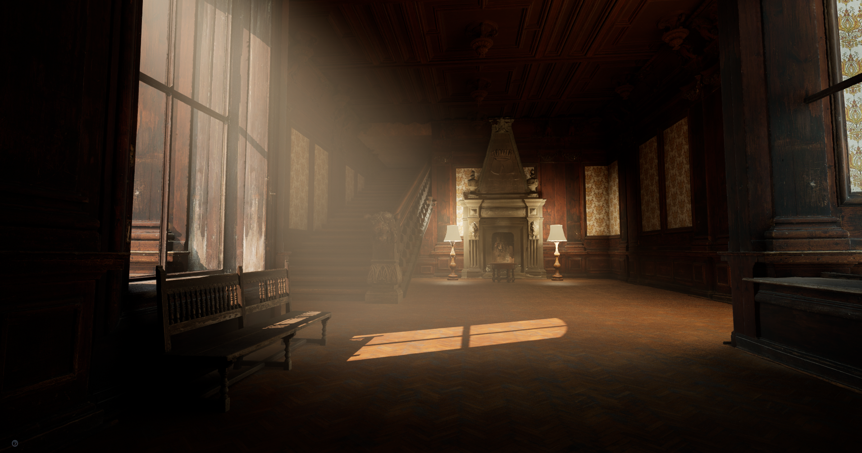

Hardware Configuration #1: Local PC, 3090 RTX (GPU) & Intel Core i9-10980XE (CPU, 36 threads), SSD
Hardware Configuration #2: Laptop, 1060 GTX (GPU) & Intel Core i7-7700HQ (CPU, 8 threads), Non-SSD

Video: https://drive.google.com/file/d/1qrOMCC0jF7w9Fqs6jbkV4lsnUCRS09QX/view?usp=sharing

Performance - Hardware Configuration #1 (3090 RTX) - Screen Percentage 100% (1080p) / Fully Dynamic Lighting
Scenario | FPS | Frame Time | Game Thread | Render Thread | GPU | Draw Calls / Tri Count | Scene Size Map
Nanite (A) | 116 | 8.57ms | 1.91ms | 5.87ms | 8.55ms | 130 / ~20k | 11.2GB (Disk) / 2.5GB (Memory)
Traditional (B) | 128 | 7.77ms | 1.62ms | 6.14ms | 7.76ms | 350 / 60-80k | 1.6GB (Disk) / 354mb (Memory)
Non-Nanite (C) | 21 | 48.18ms | 1.99ms | 7.44ms | 48.15ms | 300 / 40m-70m | 11.2GB (Disk) / 6GB (Memory)

Performance - Hardware Configuration #1 (3090 RTX) - Screen Percentage 200% (2160p) / Fully Dynamic Lighting
Scenario | FPS | Frame Time | Game Thread | Render Thread | GPU | Draw Calls / Tri Count | Scene Size Map
Nanite (A) | 57 | 17.41ms | 1.71ms | 7.04ms | 17.41ms | 160 / ~52k | 11.2GB (Disk) / 2.5GB (Memory)
Traditional (B) | 61 | 16.2ms | 1.68ms | 6.77ms | 16.27ms | 350 / 60-80k | 1.6GB (Disk) / 354mb (Memory)
Non-Nanite (C) | 13 | 74.39ms | 2.16ms | 8.13ms | 74.37ms | 300 / 40m-70m | 11.2GB (Disk) / 6GB (Memory)

Performance - Hardware Configuration #1 (3090 RTX) - Screen Percentage 100% (1080p) / Baked Lighting
Scenario | FPS | Frame Time | Game Thread | Render Thread | GPU | Draw Calls / Tri Count | Scene Size Map
Nanite (A) | 168 | 5.95ms | 1.37ms | 4.69ms | 5.95ms | 85 / 16k | 11.2GB (Disk) / 2.5GB (Memory)
Traditional (B) | 183 | 5.47ms | 1.38ms | 4.41ms | 5.46ms | 135 / 60-70k | 1.6GB (Disk) / 354mb (Memory)
Non-Nanite (C) | 31 | 32.77ms | 2.05ms | 5.73ms | 32.77ms | 135 / 30m-60m | 11.2GB (Disk) / 6GB (Memory)

Performance - Hardware Configuration #1 (3090 RTX) - Screen Percentage 200% (2160p) / Baked Lighting
Scenario | FPS | Frame Time | Game Thread | Render Thread | GPU | Draw Calls / Tri Count | Scene Size Map
Nanite (A) | 71 | 14.06ms | 1.64ms | 8.13ms | 14.06ms | 110 / 54k | 11.2GB (Disk) / 2.5GB (Memory)
Traditional (B) | 80 | 12.57ms | 1.67ms | 4.98ms | 12.56ms | 135 / 60-70k | 1.6GB (Disk) / 354mb (Memory)
Non-Nanite (C) | 24 | 42.26ms | 1.96ms | 5.78ms | 41.85ms | 135 / 30m-60m | 11.2GB (Disk) / 6GB (Memory)

Performance - Hardware Configuration #2 (1060 GTX [laptop]) - Screen Percentage 100% (1080p) / Fully Dynamic Lighting
Scenario | FPS | Frame Time | Game Thread | Render Thread | GPU | Draw Calls / Tri Count | Scene Size Map
Nanite (A) | 28 | 35.76ms | 2.02ms | 9.41ms | 35.75ms | 130 / ~20k | 11.2GB (Disk) / 2.5GB (Memory)
Traditional (B) | 32 | 30.88ms | 1.95ms | 8.89ms | 30.87ms | 350 / 60-80k | 1.6GB (Disk) / 354mb (Memory)

Performance - Hardware Configuration #2 (1060 GTX [laptop]) - Screen Percentage 100% (1080p) / Baked Lighting
Scenario | FPS | Frame Time | Game Thread | Render Thread | GPU | Draw Calls / Tri Count | Scene Size Map
Nanite (A) | 37 | 26.80ms | 2.21ms | 13.06ms | 26.77ms | 110 / 54k | 11.2GB (Disk) / 2.5GB (Memory)
Traditional (B) | 42 | 23.78ms | 1.82ms | 6.83ms | 23.77ms | 135 / 60-70k | 1.6GB (Disk) / 354mb (Memory)

Note: Scenario C omitted because hardware could not handle the scene.

Assessment
Overall, Nanite in the proper Hardware conditions (SSD) and use cases, offers a 1000x triangle density bonus within 10% performance of traditional non-Nanite workflows at 1/1000th the scene triangle count. The primary tradeoff for this is a near 8-10x multiple on disk and memory footprint.

The fact that Nanite outperforms the same meshes run through the non-nanite rendering pipeline (Scenario C in all above examples) 5.5-6x faster is a tremendous achievement for this system. Being able to render 70m triangles worth of modular architecture within 10% of the 60-70k traditional method counterparts, is significant.

This case study introduces Baked Lighting scenarios to see how lighting affects Nanite cost compared to the Traditional assets. It appears that a single dynamic directional light with 4 dynamic point lights is roughly a 1.44x scene cost multiplier. This was the same multiple for both Nanite, Traditional and Non-nanite which is encouraging due to concerns that lighting could potentially be more expensive on Nanite meshes.

In Hardware Configuration #2, which uses a mechanical HDD, it shows a minor 2-5% slowdown compared to SSD. In both dynamic and baked lighting, the 1.25-1.44x delta between the two approaches was still consistent, but Nanite struggled to perform as well as the traditional method with ~15% worse performance.

However, knowing that the base Nanite meshes are 1000x more dense pre-Nanite in this Case Study, the performance delta only being 5% worse than SSD is still fairly encouraging. On hardware that supports Nanite, but may have non-SSD disk storage, a scaled back approach, such as a 100:1 triangle ratio may be a better approach than 1000:1, and that same line of thinking would apply to a traditional pipeline anyway, given that both cases above still only ran at 30-40 FPS on the hardware.

Questions/Follow Up Tests
- How does baked lighting compare visually in Nanite vs. Traditional scenarios? How does Lumen interact with Nanite versus Traditional? This will be explored in Case Study #3.

Case Study #3: TIE Fighter Dynamic vs. Baked Lighting

Introduction
This case study seeks to answer the following questions:
- How does baked lighting visually differ from dynamic lighting when using Nanite/Traditional?
  - Short Answer: Baking lighting tends to be much darker than dynamic with the same settings for. Baked is obviously worse than dynamic visually for all mesh types. Both lighting types expose some issues with Nanite. Dynamic lighting has more artifacts but less visual clarity when it's correct.

A simple scene was created using a single Nanite-quality TIE fighter with a simple default light rig (one sunlight, one skylight). Comparison shots below. Performance is not a consideration for this case study, just a simple visual comparison/exploration.

Fully Dynamic Lighting
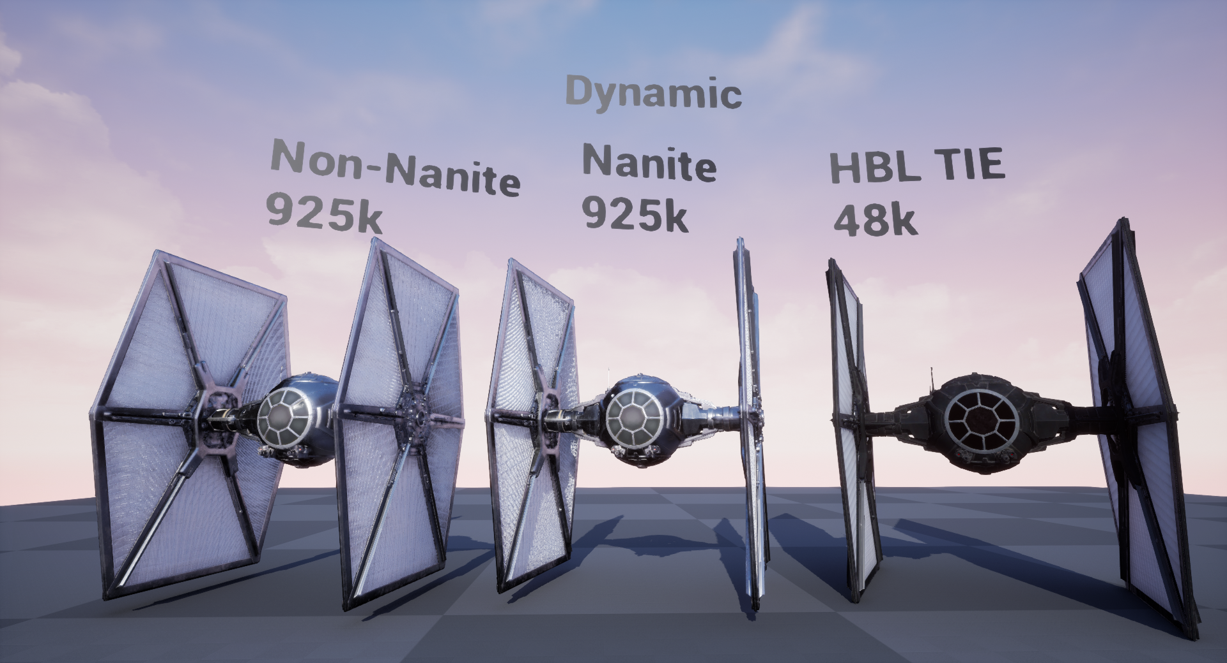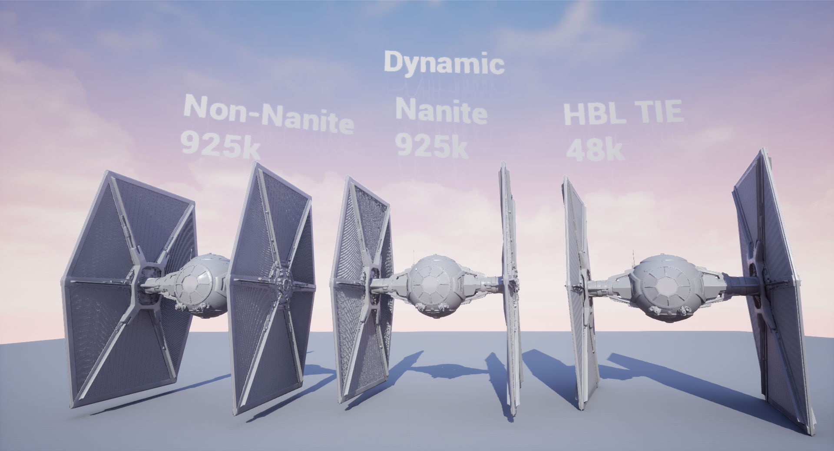
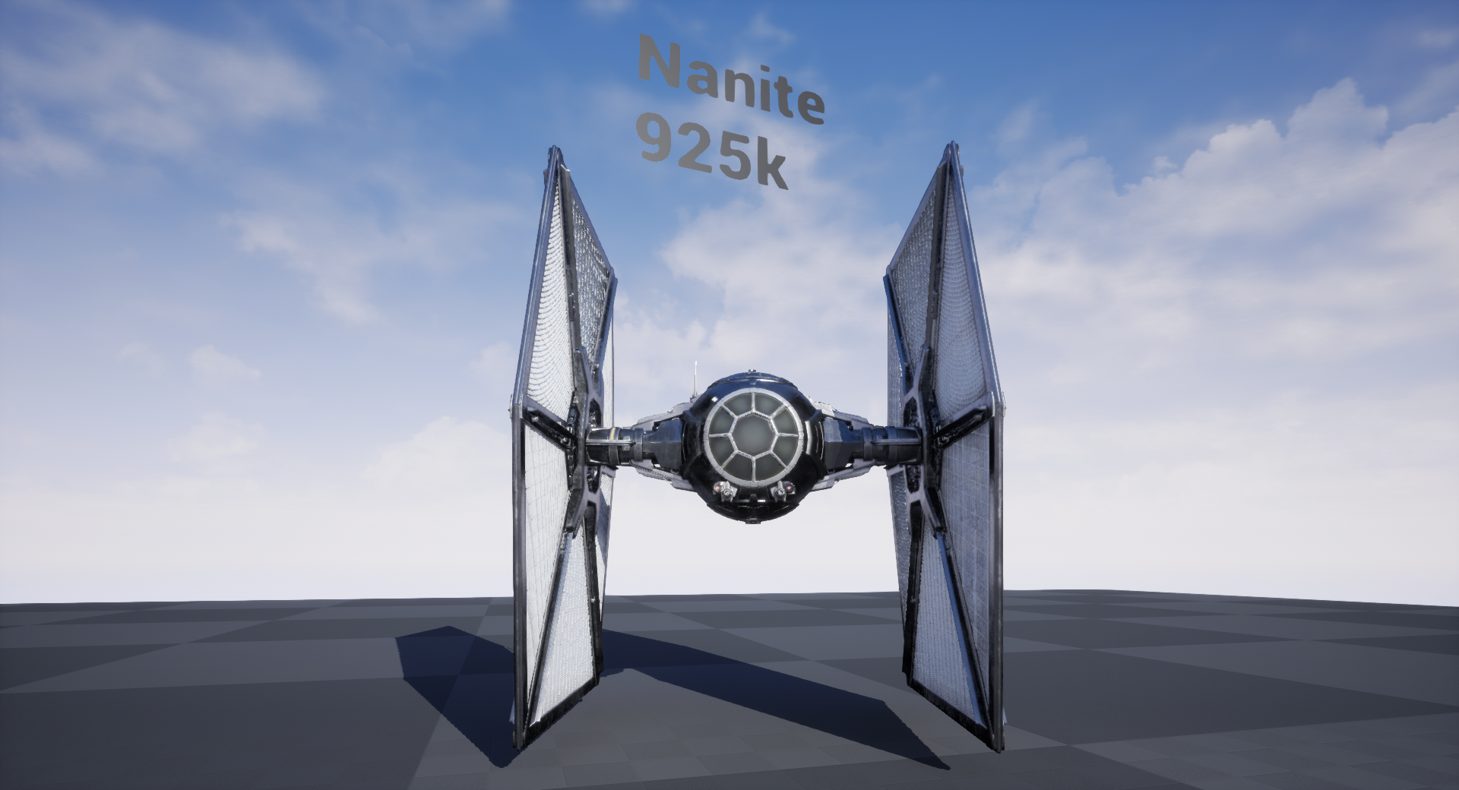
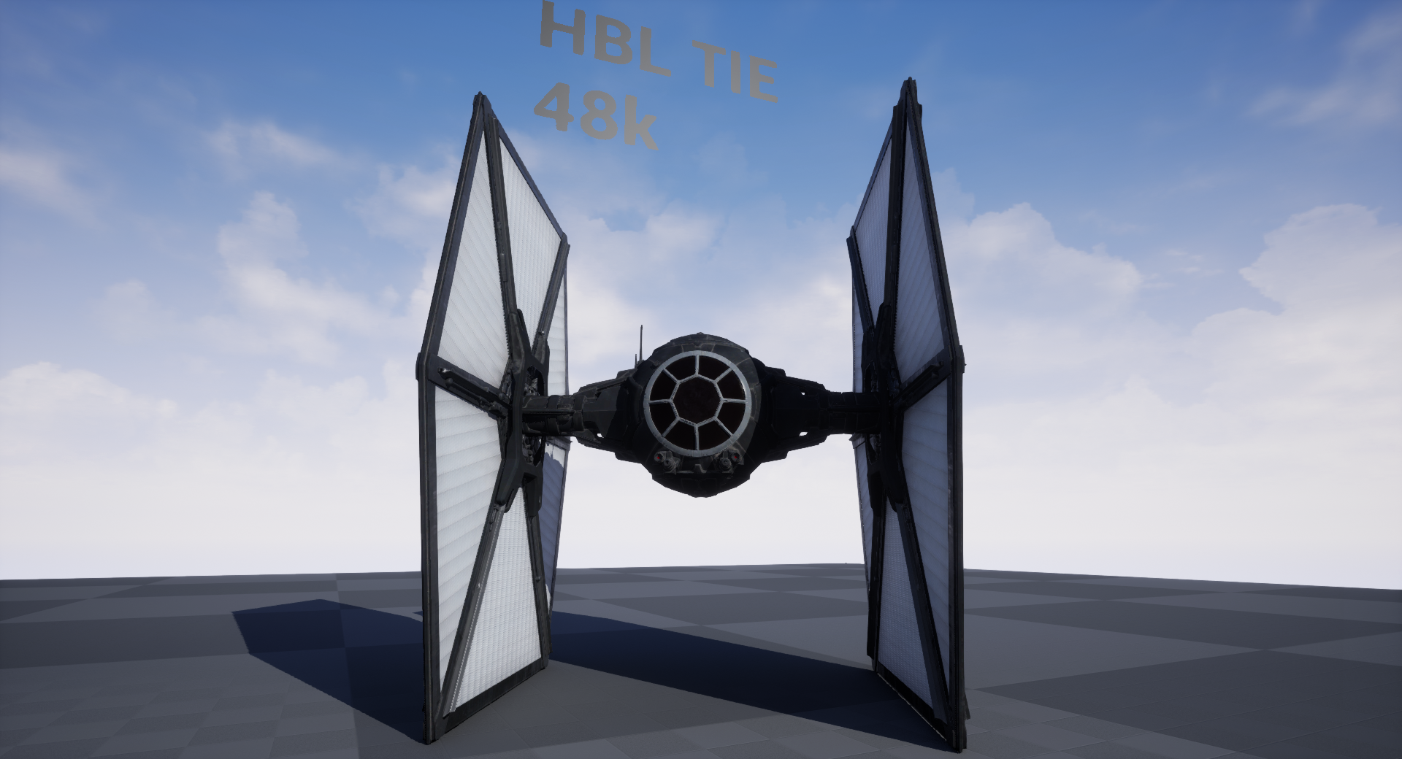
Note: HBL TIE shader was based on UnifiedSrf, so a simplified UE material was created. Not a 1:1 shader.
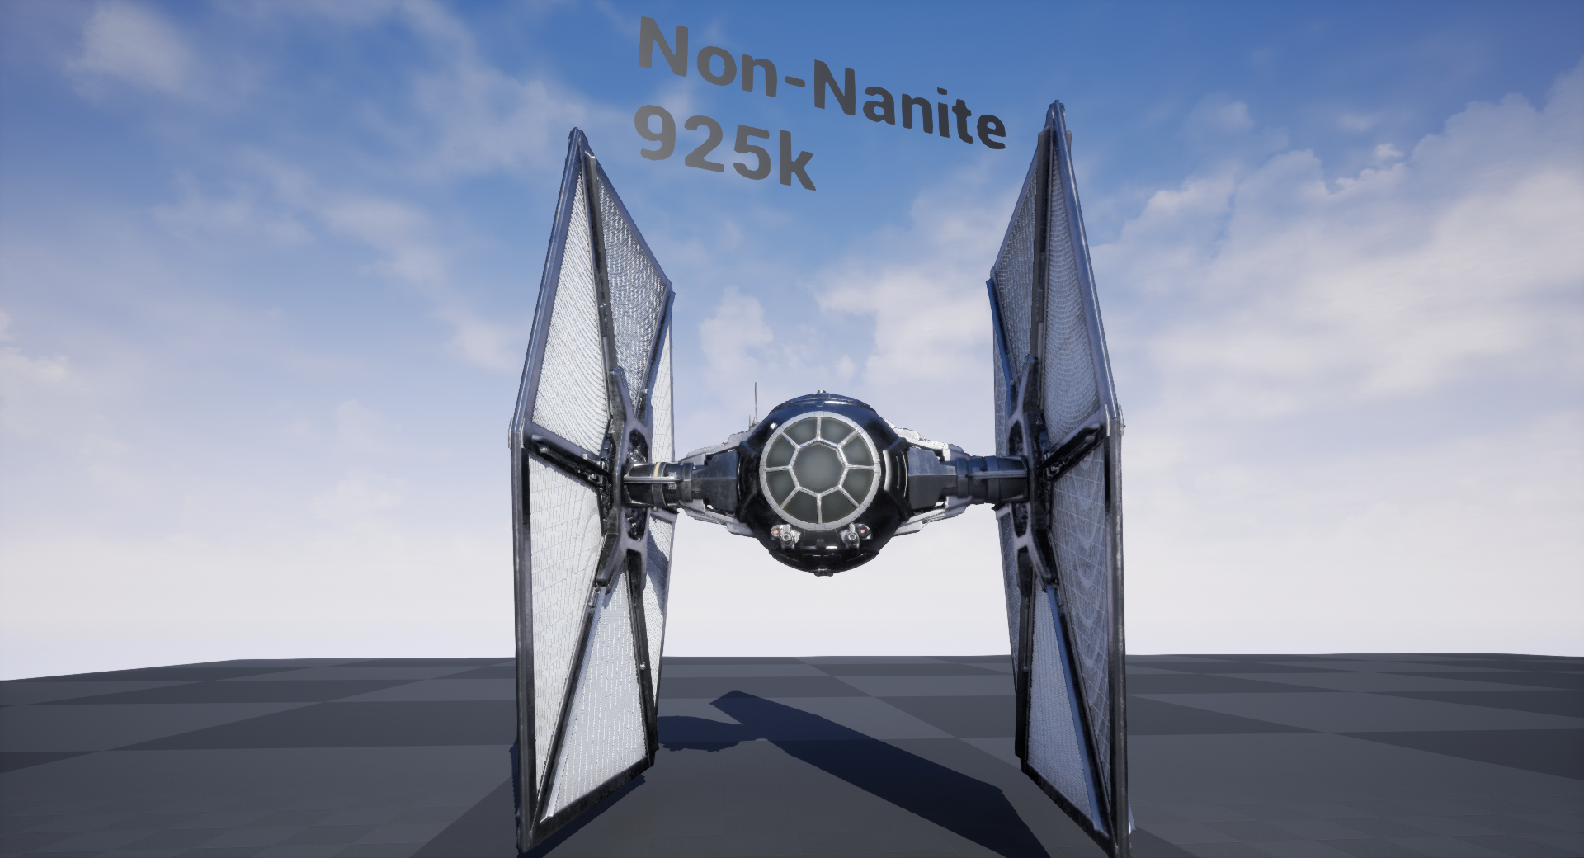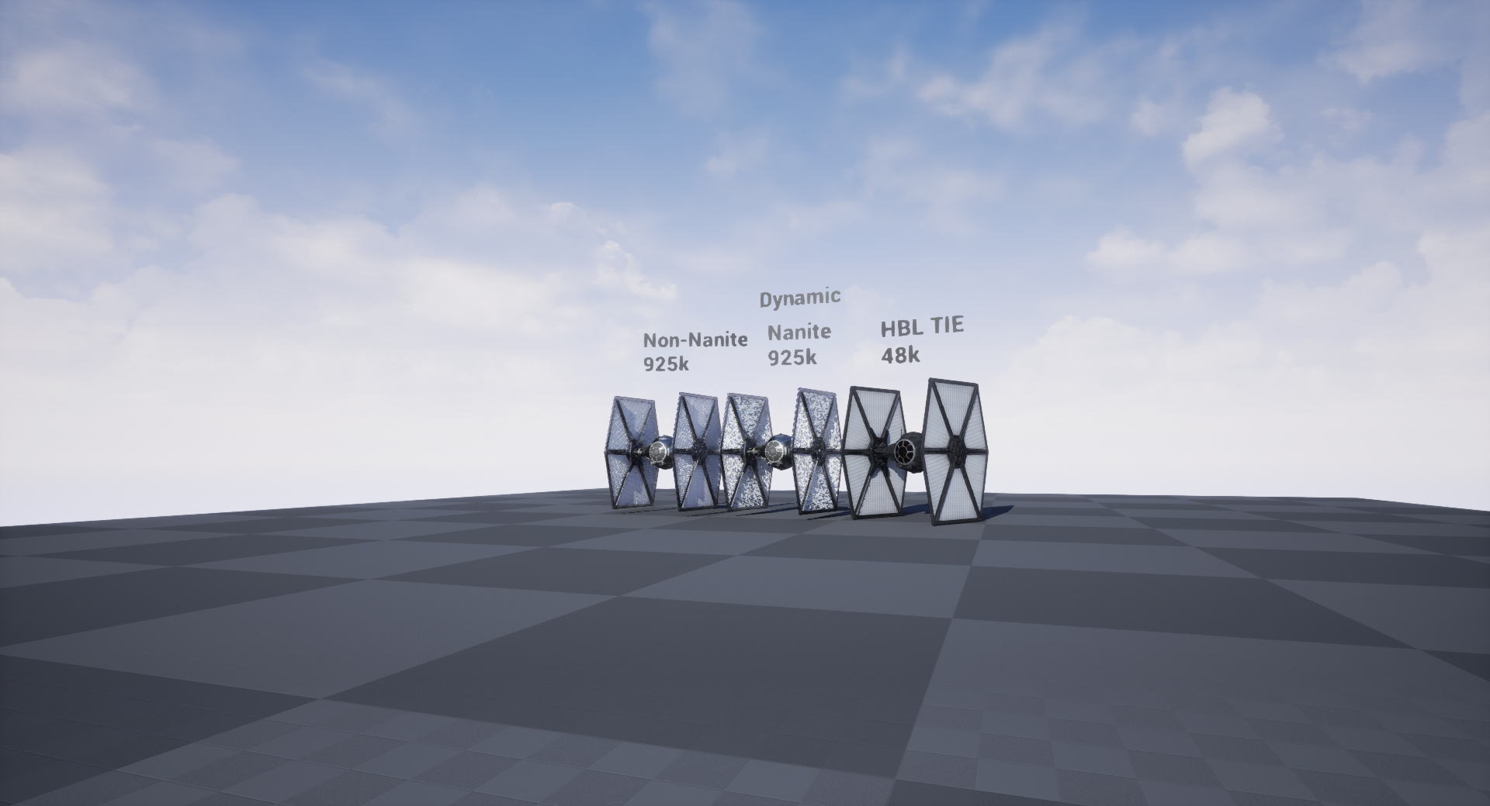

Baked Lighting
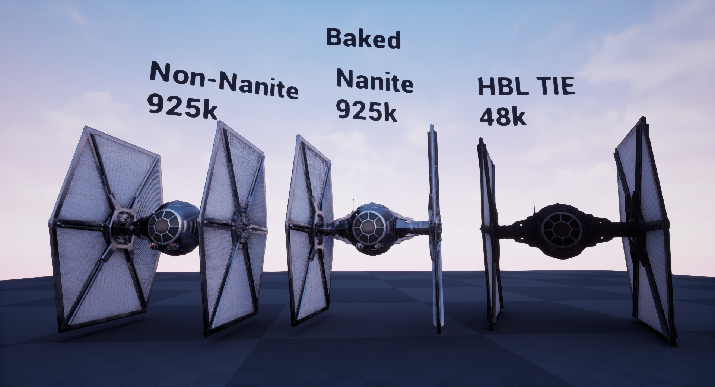

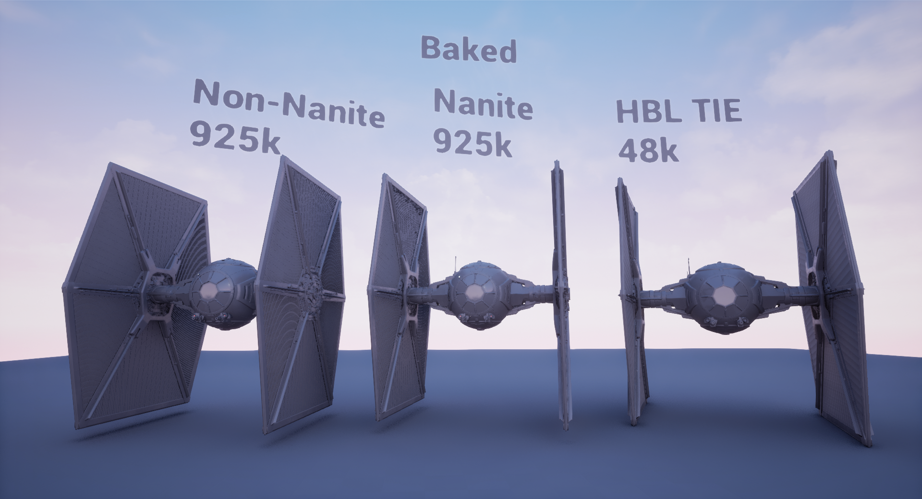
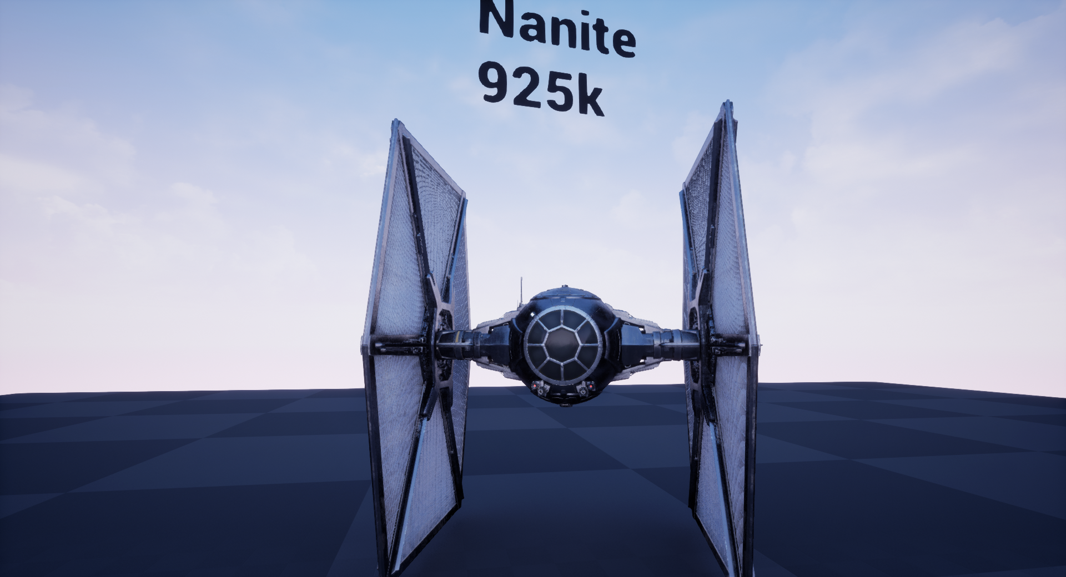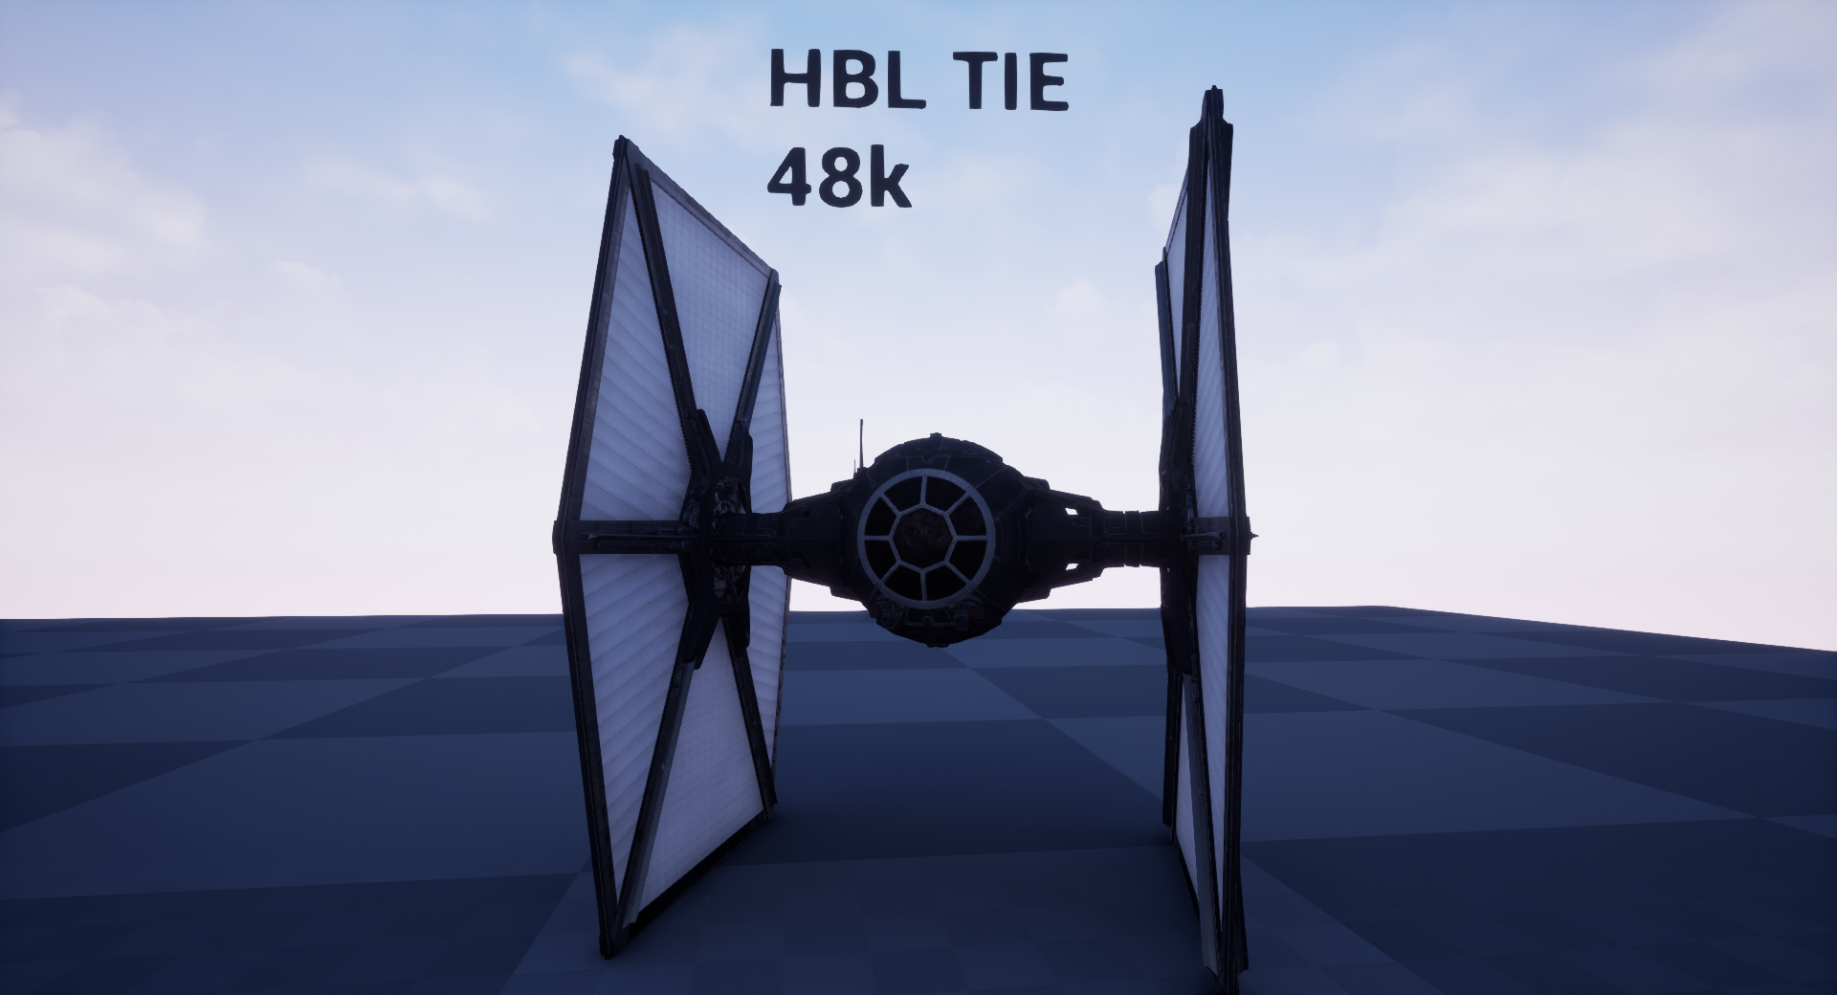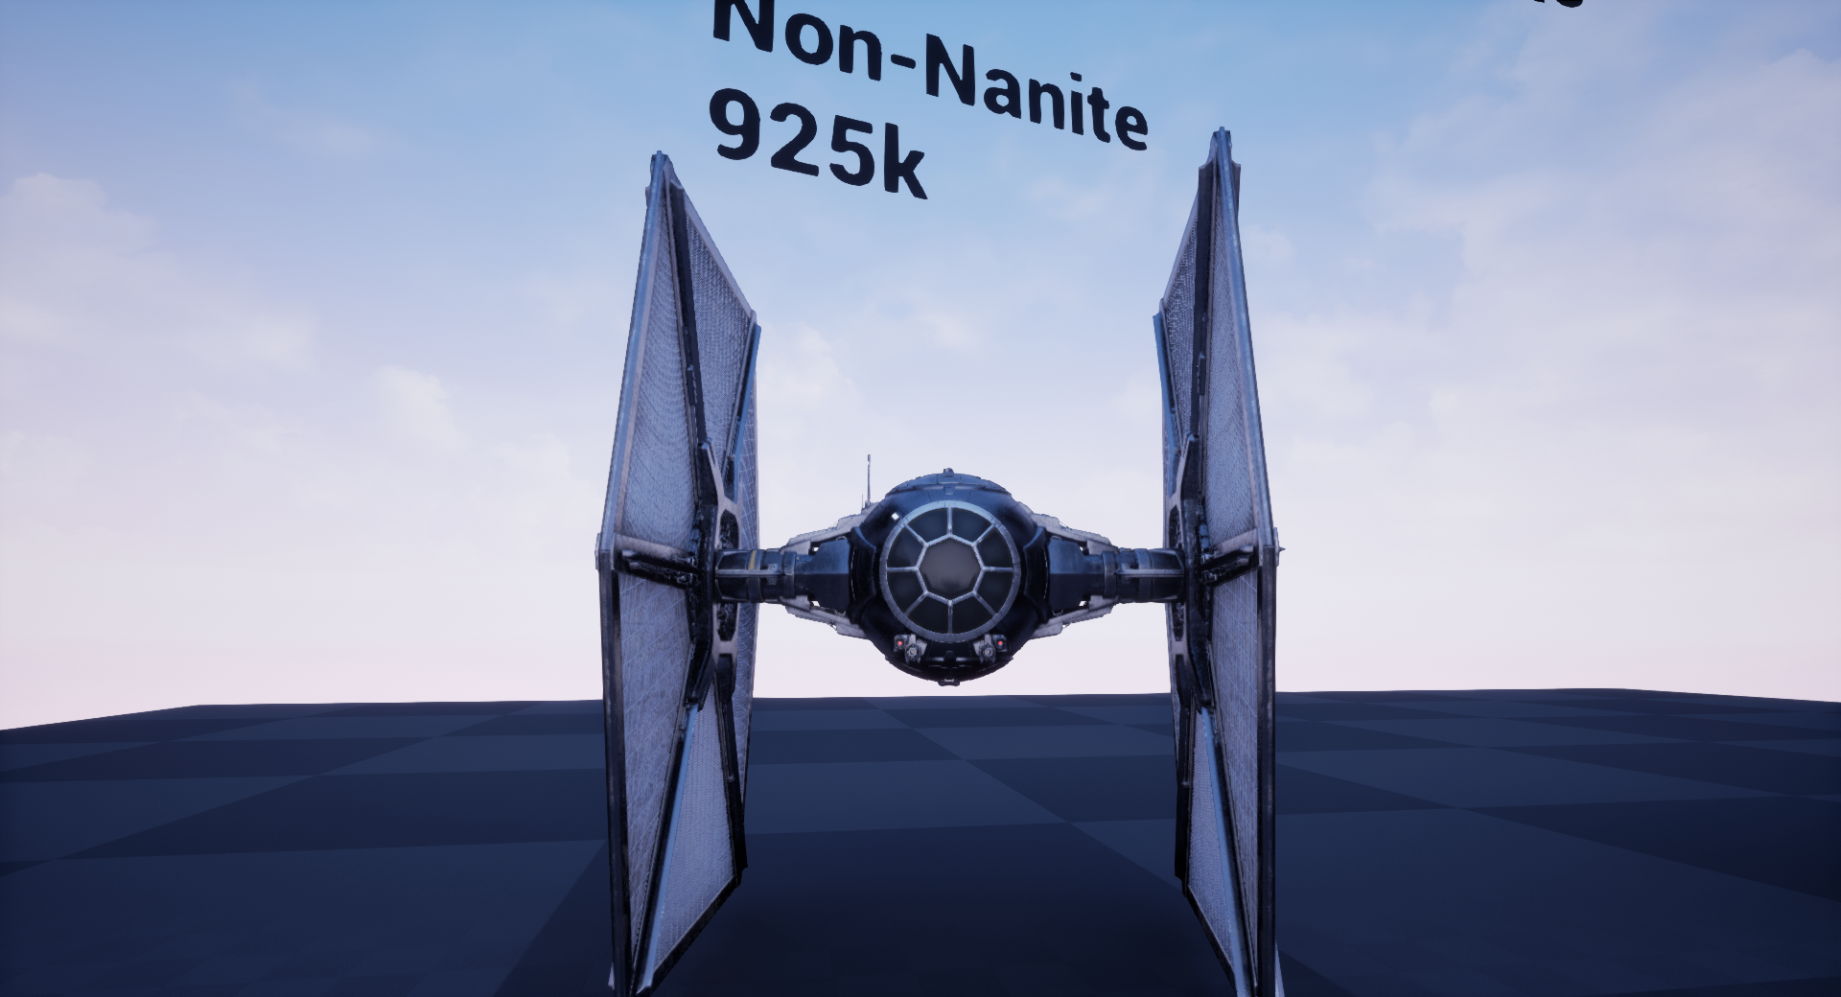
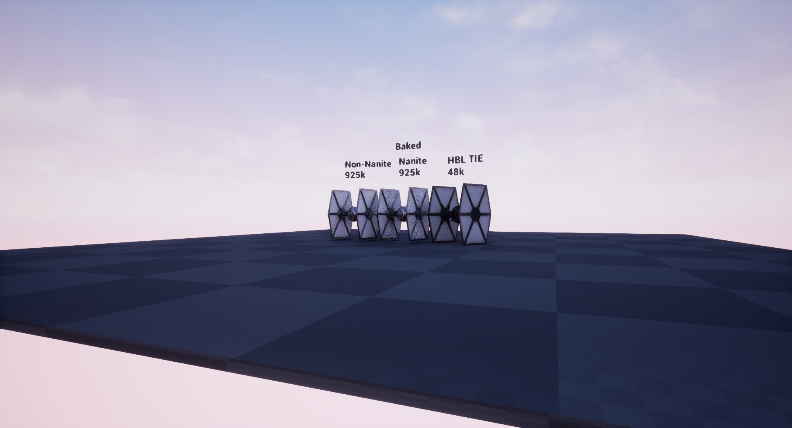

Smooth-Shaded Closeups (Wing Detail)
Dynamic
Nanite (925k tris)
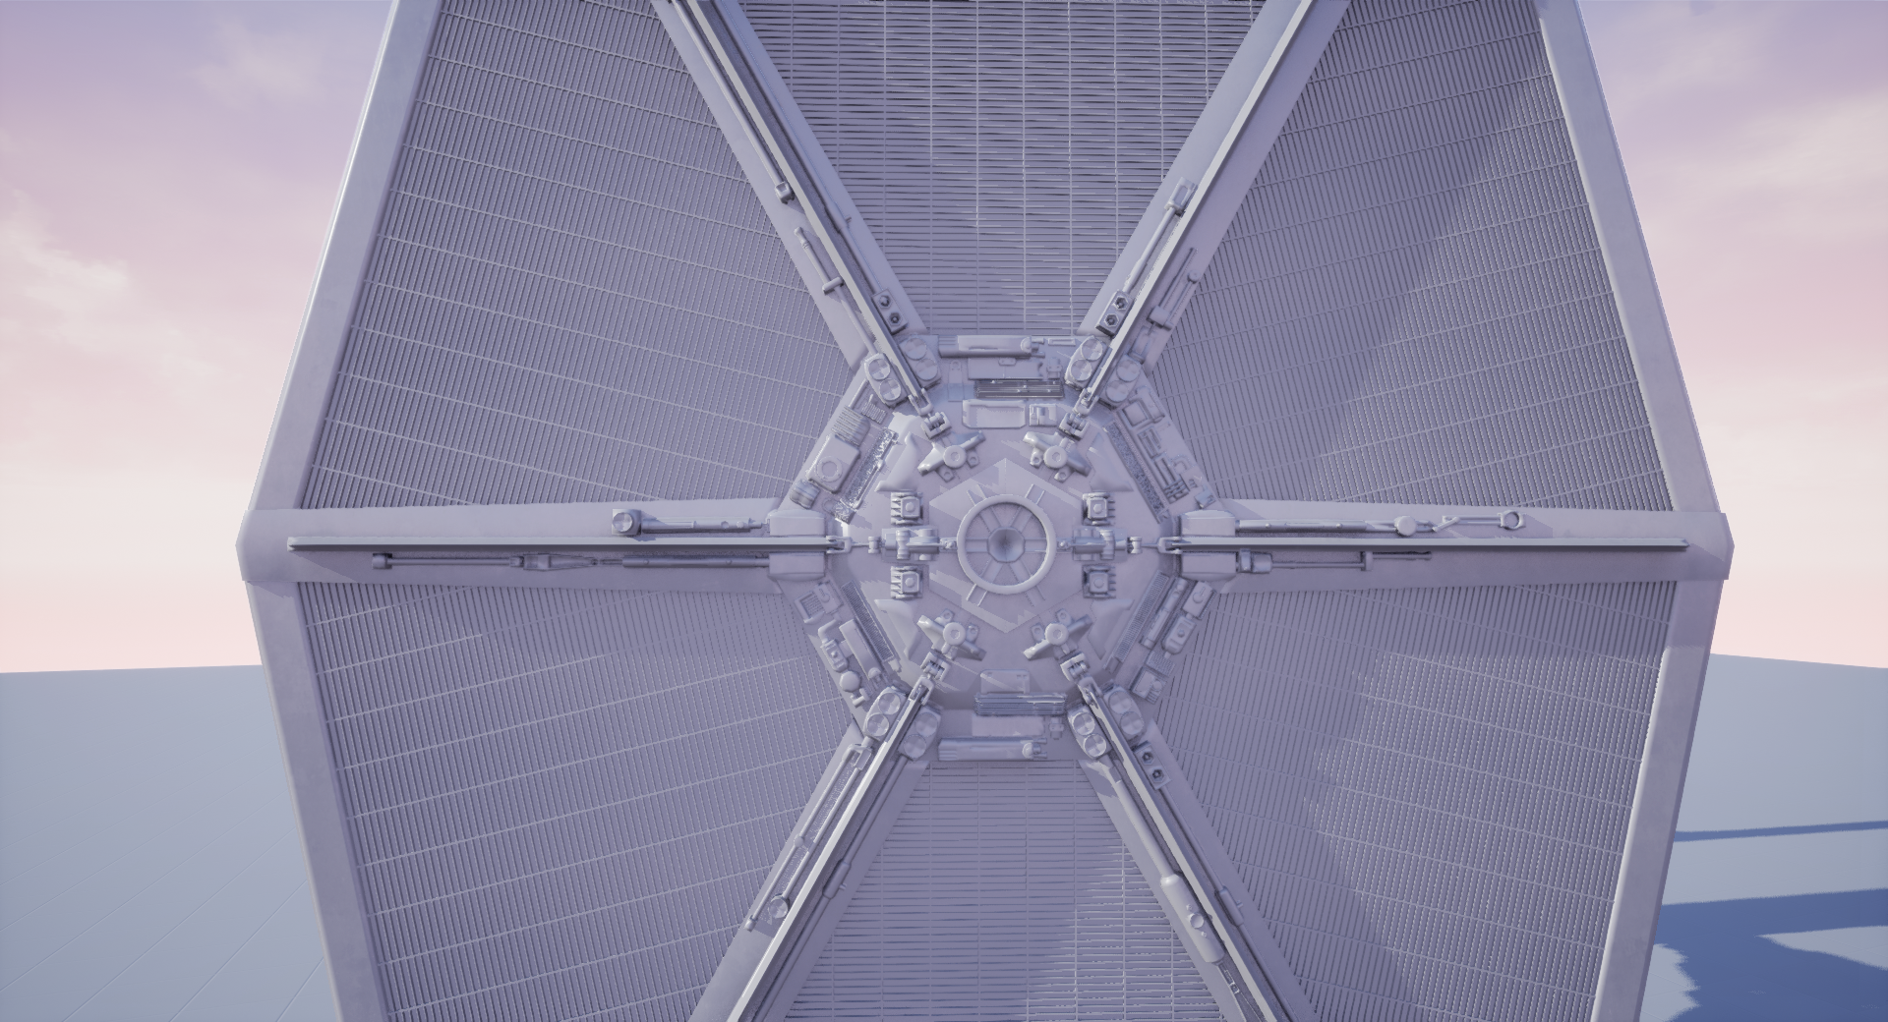
Non-Nanite (925k tris)
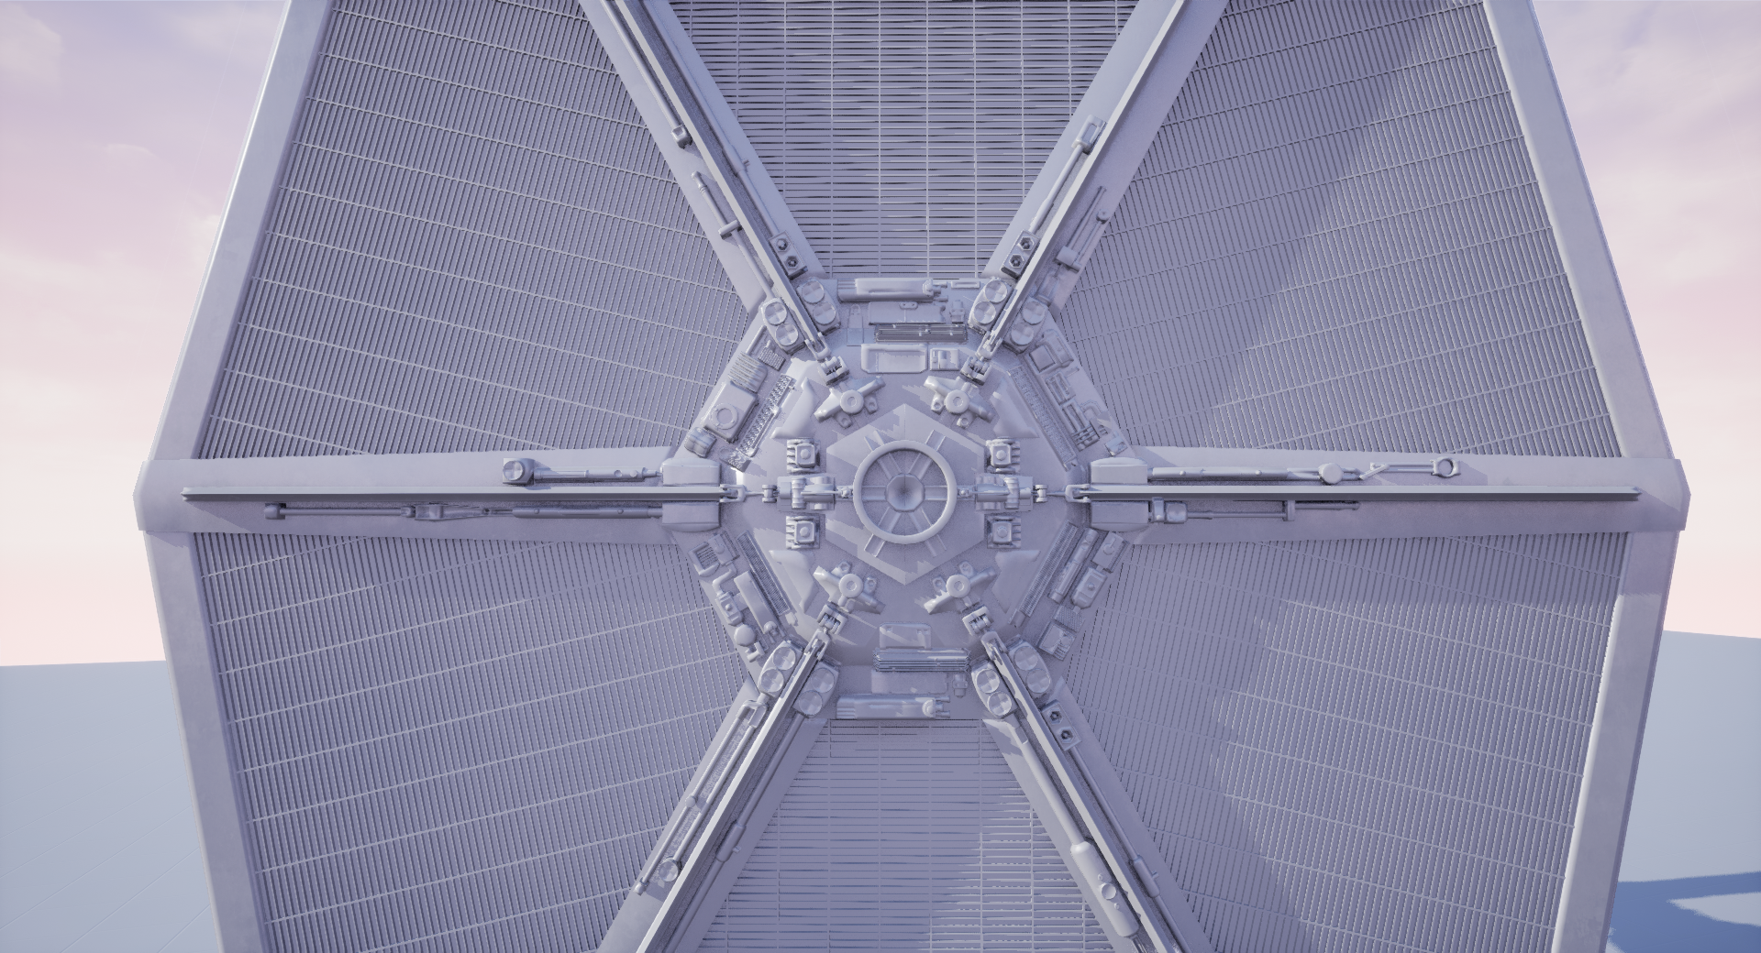
HBL TIE (48k tris)
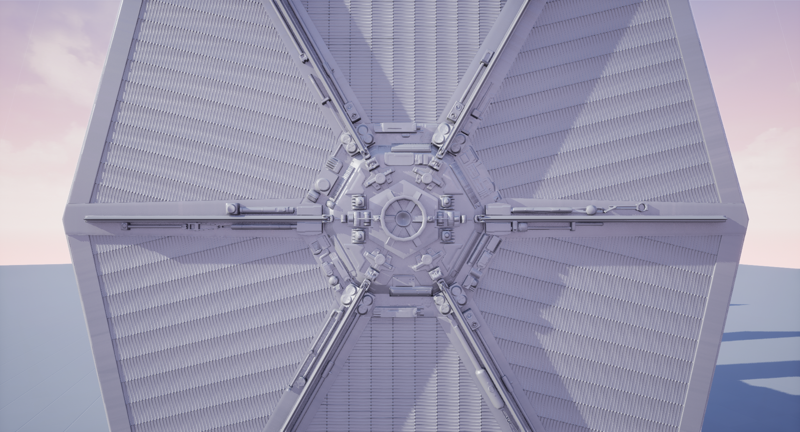

Baked
Nanite (925k tris)
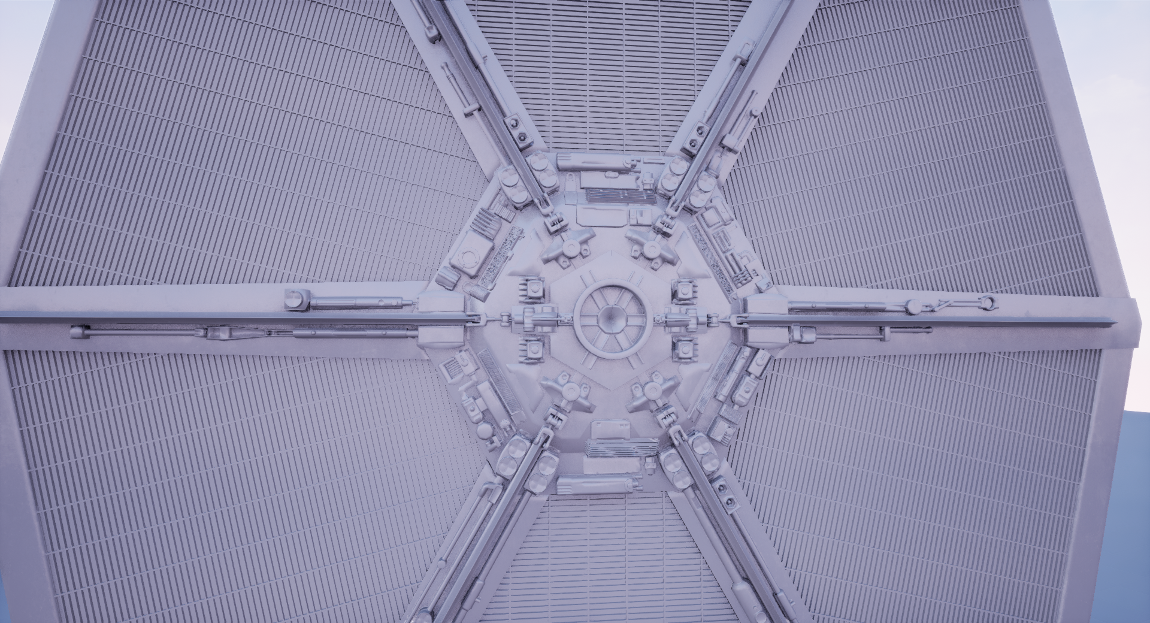
Non-Nanite (925k tris)
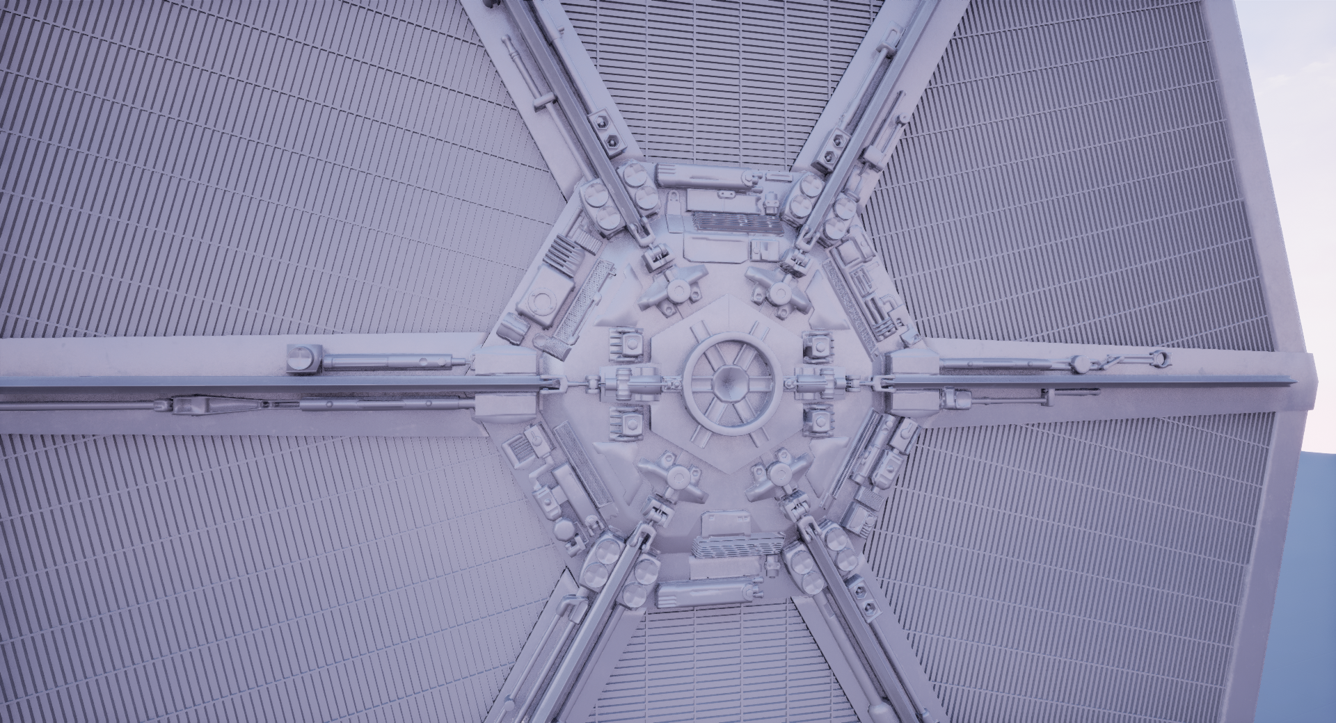
HBL TIE (48k tris)
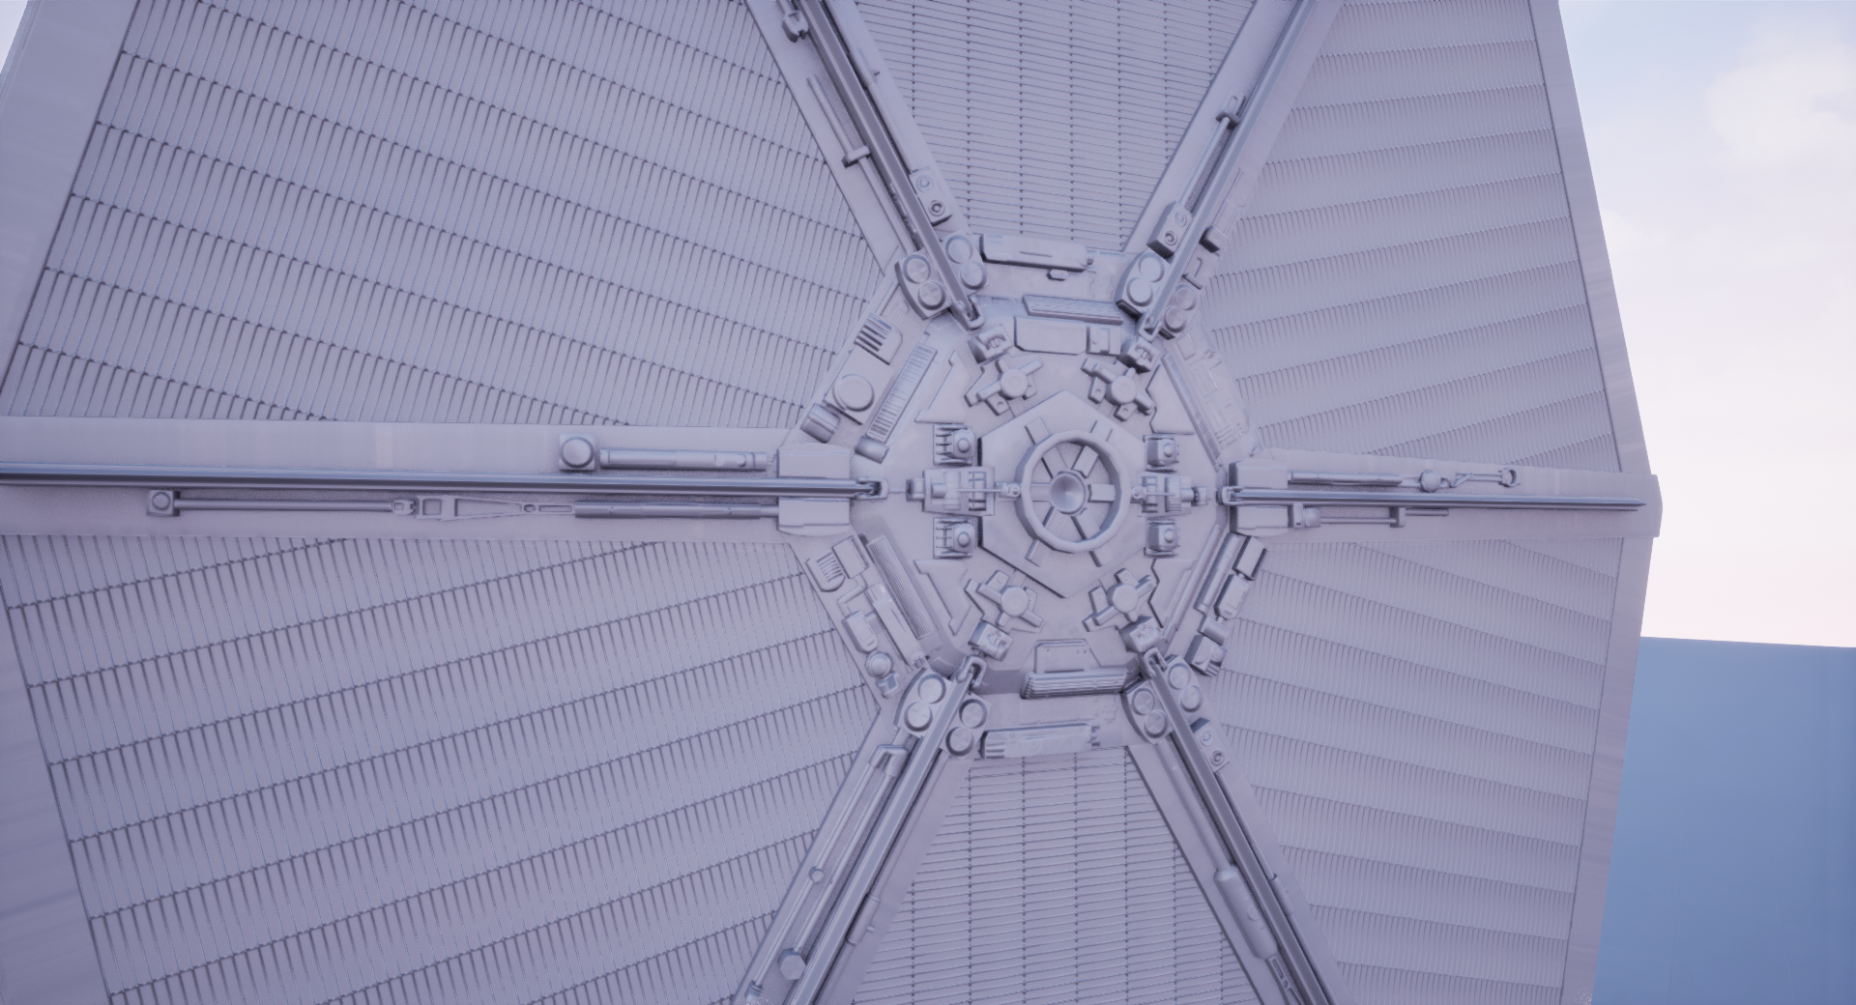

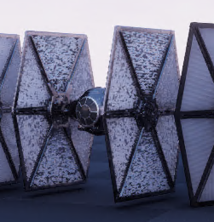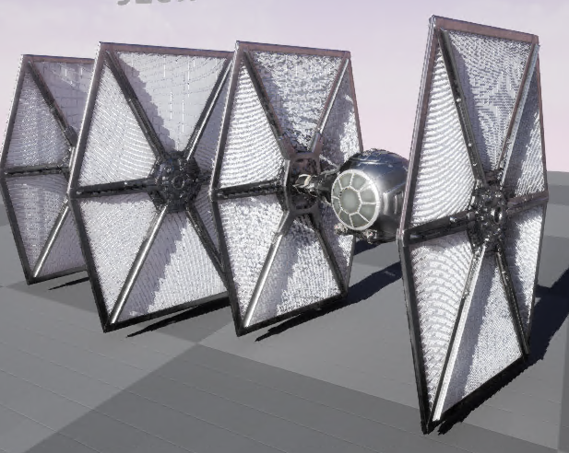
Examples of Nanite thin mesh z-fighting and high frequency pattern artifacts. Left- Nanite mesh | Right - Non-nanite and Nanite mesh.

Assessment
Dynamic lighting interacts similarly with all 3 cases. This test really exposes the issues Nanite has with thin and high frequency geometry. In the distant shot, you can see the back clusters of the Nanite TIE z-fighting through the mesh. The high frequency pattern of the TIE wings really break at distance in the Nanite and Non-nanite versions.

There are some really nice nuanced self-shadows within the ridges up close on the Nanite TIE. The effect breaks quickly at virtually all distances besides closeups for both Nanite and non-Nanite but that's more-or-less a side effect of real-time dynamic lighting on super dense surfaces.

An obvious solution to this is not present, because of the way cluster generation works, and you can’t just artificially thicken TIE wings that need to look the way they look. In situations where you have thin/high-frequency patterns across near-planar spans, it may be wise to keep them planar and rely on normal maps for cleaner renders. Another idea is to detach the edge between the front and back, so Nanite cannot cluster verts on both sides within one cluster.

Baked lighting is always a challenge in UE projects because the end result is almost always far darker than the dynamic scenario with the same settings post-bake, making the preview inaccurate (and longer iteration time). UE5’s default Auto Exposure/Eye Adaptation post-processing feature interferes with Baked Lighting greatly and darkens scenes many times more than the Dynamic counterpart.

Baked lighting can be a large fidelity loss, shadow crispness within the TIE’s surfaces and on the ground plane are significantly less detailed. Note: It is possible to get better parity out of baked lighting than the tests above, they were quick tests to specifically explore how lighting interacts with Nanite meshes vs. not. Since Nanite uses a proxy mesh for light baking it should be anticipated for baked lighting to be more 1:1 with a TIE more similar to the HBL TIE.

Case Study #4: Flying TIE Fighters

Introduction
This case study seeks to answer the following questions:
- How does Nanite work as Movable Static Meshes?
- How does Nanite perform as Movable versus traditional methods?

A scene was created with 10 TIE fighters flying across the viewport at varying depths. Scenario A has all TIE fighters as Nanite meshes. Scenario B has all TIE fighters as traditional mesh setup with LOD’s. Scenario C disables Nanite on the high quality TIE. The traditional scenario uses a TIE fighter asset from Project HBL, that is a bit more dense than most game assets would be, but is representative of a high quality asset versus an even higher fidelity Nanite mesh.

Hardware Configuration #1: PC, Quadro 5000 RTX, Intel Xeon X-5660, SSD

Nanite Video: https://drive.google.com/file/d/1uopk7h4X5KzqHsEDLfy1jwIbt4Urozzf/view?usp=sharing
Traditional Video: https://drive.google.com/file/d/1LOJ1XiF_hsHIQxDbXn_vEmNKy_qY9zcZ/view?usp=sharing
Non-Nanite Video: https://drive.google.com/file/d/1AtS9Ulnk1n1unMfeAA75F7KSvqfACdcb/view?usp=sharing

Performance - Hardware Configuration #1 (5000 RTX) - Screen Percentage 100% (1080p)
Scenario | FPS | Frame Time | Game Thread | Render Thread | GPU | Draw Calls / Tri Count | Scene Size Map
Nanite (A) | 95 | 10.58ms | 2.64ms | 10.40ms | 10.57ms | 77 / NA | 728mb (Disk) / 192MB (Memory)
Traditional (B) | 92 | 10.79ms | 2.87ms | 10.55ms | 10.77ms | 94 / 106k | 137MB (Disk) / 265MB (Memory)
Non-Nanite (C) | 81 | 12.31ma | 2.80ma | 12.12ma | 12.31ma | 131 / ~8m | 728mb (Disk) / 273MB (Memory)

Assessment
Nanite transitions are always based on camera proximity so having the meshes move instead of the camera is still technically the same. Faster velocity in either case potentially introduces visible Nanite transitions and Nanite artifacts. Whether or not that is as obvious as typical LOD pops is going to be case-by-case.

In this particular test, the high frequency/thin mesh artifacts possible from Nanite clustering are egregious.

The traditional scenario is 75x less triangle count and performs 1.02x worse. The HBL TIE uses giant 8k textures so the memory footprint at runtime is comparable.

Note: The 100x -> 2x performance trend from other case studies does not hold up here because of different hardware. The RTX5000 is a much weaker card so we see the breakeven being closer to 100x. The Nanite triangle-to-performance ratio should be measured/established per-platform.

Case Study #5: The Trial of Ten Thousand Star Destroyers!

Introduction
This case study seeks to answer the following questions:
- Can Nanite handle 10,000 instances of a dense mesh?
  - Short Answer: Yes
- How does Nanite handle great distances?
  - Short Answer: Yes, but it requires render CVAR tuning to fix artifacts/imposter issues.
- How do 10k instances compare individually and as HISM?
  - Short Answer: HISM offers a significant runtime improvement because of instancing.

A scene was created using a procedural blueprint to create a random grid of 10,000 instances of a 1 million triangle Star Destroyer with Nanite active across a screen distance that would ordinarily contain a significant amount of sub-pixel geometry.

Scenario A is this scenario with all the Star Destroyers functioning as shared instances within a HISM (instancing system that allows for individual LODing and culling but combined/shared draws).

Scenario B deactivates the HISM and shows performance with each Star Destroyer being an individual Static Mesh Actor.

Scenario C fixes a far distance rendering artifact with a rendering CVAR (console variable) and re-measures performance.

A Nanite-disabled scenario was excluded because it cannot run.

Hardware Configuration #1: PC, Quadro 5000 RTX, Intel Xeon X-5660, SSD

View #1 - All Instances In View
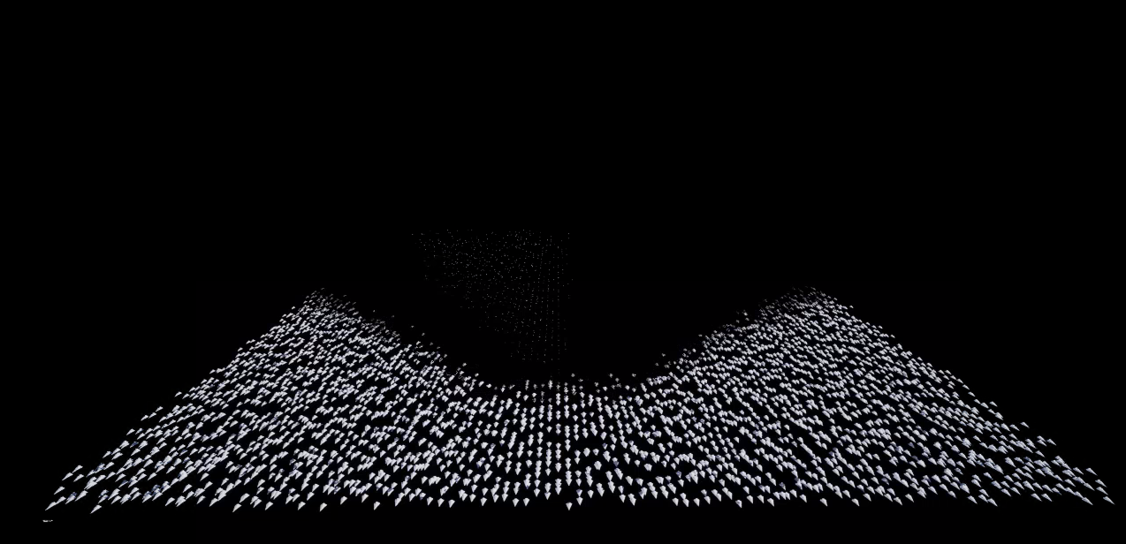
Note: See Assessment section below for explanation and fix of above visual artifact.

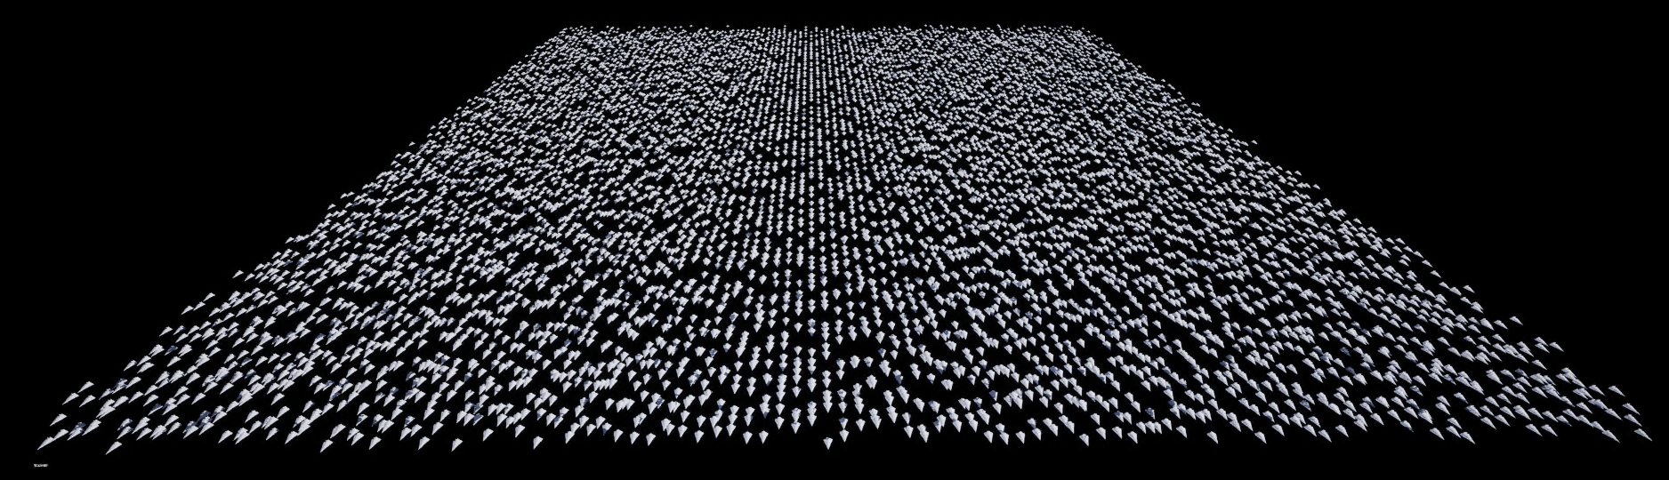
Note: 10,000 star destroyers (1 mil tris each in Nanite) fixed with r.Nanite.ImposterMaxPixels 5 -> 1.

Performance - View #1 (5000 RTX) - Screen Percentage 100% (1080p) / Fully Dynamic Lighting
Scenario | FPS | Frame Time | Game Thread | Render Thread | GPU | Draw Calls
Nanite HISM (A) | 133 | 7.53ms | 1.95ms | 7.33ms | 7.52ms | 49
Nanite Indiv. (B) | 85 | 11.75ms | 8.47ms | 11.35ms | 11.73ms | 49
Nanite HISM (Fixed Visual) (C) | 130 | 7.67ms | 1.95ms | 7.67ms | 7.67ms | 49

View #2 - Corner View - Overdraw Stress Test
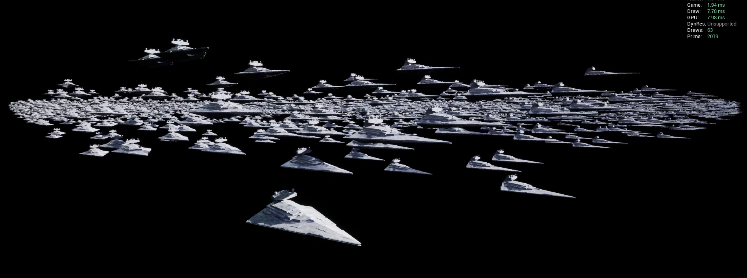

Performance - View #2 (5000 RTX) - Screen Percentage 100% (1080p) / Fully Dynamic Lighting
Scenario | FPS | Frame Time | Game Thread | Render Thread | GPU | Draw Calls
Nanite HISM (A) | 122 | 8.19ms | 1.99ms | 8.01ms | 8.18ms | 63
Nanite Indiv. (B) | 88 | 11.37ms | 7.84ms | 10.98ms | 11.35ms | 63
Nanite HISM (Fixed Visual) (C) | 121 | 8.21ms | 2.00ms | 8.00ms | 8.20ms | 63

Assessment
Overall, Nanite does a great job handling high quantities of instances (as long as it's the same mesh) especially when configured as HISM instances. There is a steep 1.38x performance degradation when switching to individual assets on Frame Time and also a steep ~7x degradation of Game Thread. This is likely due to a large static draw list the CPU has to calculate to help the GPU with pre-pass/occlusion. The delta between instancing vs. not is significant enough for high quantities being wrapped in a HISM to be a Best Practice.

In View #1, there was a large rendering artifact far in the distance shown in the first image associated with that view. Nanite renders 12-angles worth of imposters (flat cards representing geometry to help with rendering performance) that display after some pixel-to-screen ratio is reached. That is controlled by the command r.Nanite.ImposterMaxPixels which defaults to 5 and was updated to 1 to decrease the number of pixel occupation required to switch to imposters. Pushing that distance back to fix the artifact only had a fractional impact on performance.

Having a stacked view (View #2) with a lot of overlap performs about 8% worse than a bird’s eye view which is common in real-time rendering. There will always be more expensive views in real-time but Nanite still handles overlapping instances (10,000 of them!) pretty strongly. Overdraw/overlapping assets are always a concern but Nanite does not appear to require special handling compared to traditional methods.

Case Study #6: Large Landscape

Introduction
This case study seeks to answer the following questions:
- How does Nanite handle a maximum number of instances?
  - Short Answer: There appears to be a maximum number of instances/tri counts within an HISM, but otherwise performs well. High instance counts may stress draw thread. The instance counts seem to scale based on hardware somehow.
- How does Nanite an open world with long sightlines and dense cliffs and scatter?
  - Short Answer: Because of how Nanite works (preventing sub-pixel geo) it performs pretty well.
- How does the triangle-to-performance ratio differ on different hardware with the same scene?
  - Short Answer: It does differ between hardware configurations. The range between the two was 5% to 38% better in favor of Nanite at 1000-to-1 triangles between a 5000RTX and 3090RTX (3090RTX is ~75% stronger).

A scene was created in Houdini (thanks Jeff!) to generate/place cliffs/rocks/scatter at point cloud locations along a procedural landscape with a flexible number of instances, landscape size/states, etc. MegaScans’ meshes were used to populate the scene since they offer both Nanite and traditional quality/density assets (similar to the modular architecture scene).

Scenario A is the landscape scene as Nanite meshes, with millions of triangles and ~168k instances within HISM instances. The triangle counts in this scenario are so high without Nanite, it surpasses the 200m tri limit.

Scenario B is the scene instances replaced with traditional density meshes (15-30k tris each with LOD’s).

The test will compare performance of the two scenarios on the two hardware configurations below from a flythrough cam and a still cam.

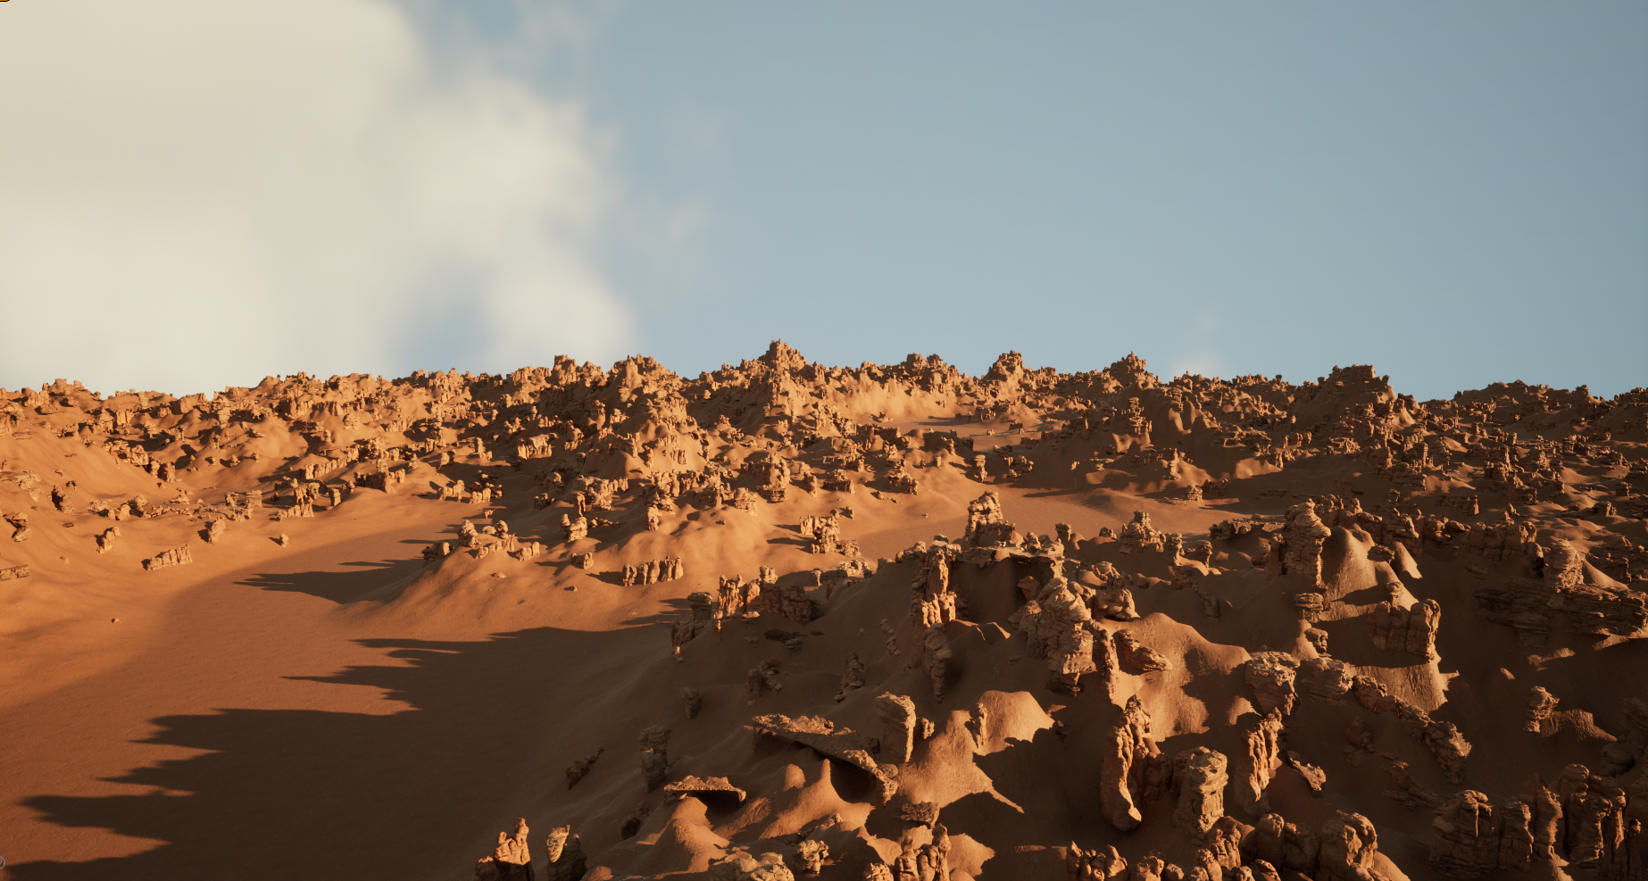

Hardware Configuration #1: Local PC, 3090 RTX (GPU) & Intel Core i9-10980XE (CPU, 36 threads), SSD
Hardware Configuration #2: PC, Quadro 5000 RTX, Intel Xeon X-5660, SSD

Performance - Hardware Configuration #1 (3090 RTX) - Flythrough
Scenario | FPS | Frame Time | Game Thread | Render Thread | GPU | Draw Calls / Tri Count | Scene Size Map
Nanite (A) | 163 | 6.14ms | 1.64ms | 6.14ms | 6.14ms | 115 / NA | 7.2GB (Disk) / 2.7GB (Memory)
Traditional (B) | 117 | 8.54ms | 1.74ms | 5.16ms | 8.55ms | 133 / 40m | 4.5GB (Disk) / 2.7GB (Memory)

Performance - Hardware Configuration #1 (3090 RTX) - Still/Long View
Scenario | FPS | Frame Time | Game Thread | Render Thread | GPU | Draw Calls / Tri Count | Scene Size Map
Nanite (A) | 176 | 5.65ms | 1.48ms | 5.65ms | 5.65ms | 72 / NA | 7.2GB (Disk) / 2.7GB (Memory)
Traditional (B) | 100 | 9.97ms | 1.61ms | 4.68ms | 9.97ms | 181 / 72m | 4.5GB (Disk) / 2.7GB (Memory)

Performance - Hardware Configuration #2 (5000 RTX) - Flythrough
Scenario | FPS | Frame Time | Game Thread | Render Thread | GPU | Draw Calls / Tri Count | Scene Size Map
Nanite (A) | 65 | 15.45ms | 2.47ms | 15.24ms | 15.21ms | 115 / NA | 7.2GB (Disk) / 2.7GB (Memory)
Traditional (B) | 68 | 14.64m | 2.44ms | 14.43ms | 14.63ms | 133 / 40m | 4.5GB (Disk) / 2.7GB (Memory)

Performance - Hardware Configuration #2 (5000 RTX) - Still/Long View
Scenario | FPS | Frame Time | Game Thread | Render Thread | GPU | Draw Calls / Tri Count | Scene Size Map
Nanite (A) | 108 | 9.21ms | 2.34ms | 8.99ms | 9.19ms | 115 / NA | 7.2GB (Disk) / 2.7GB (Memory)
Traditional (B) | 78 | 12.76ms | 2.35ms | 12.52ms | 12.73ms | 181 / 72m | 4.5GB (Disk) / 2.7GB (Memory)

Visual Comparison
Nanite
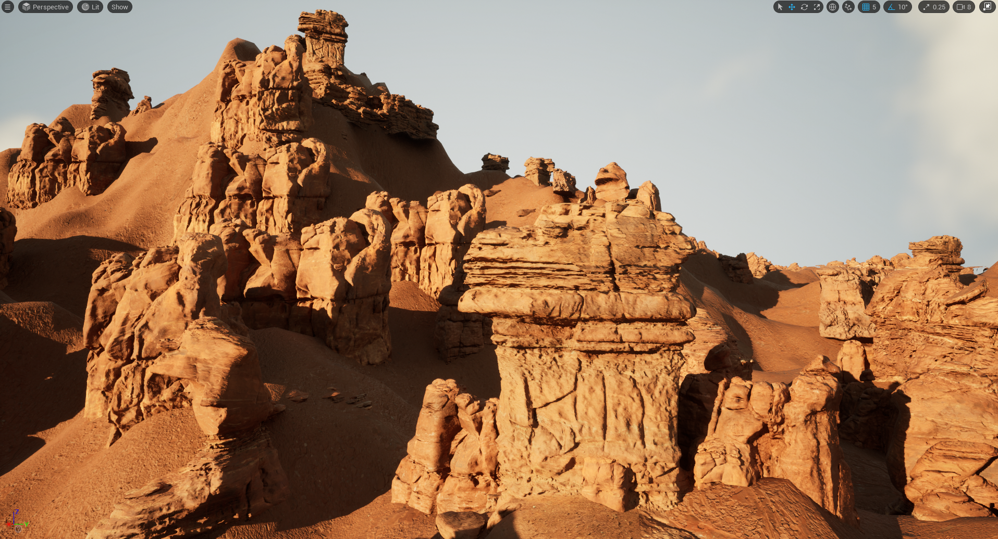
Traditional
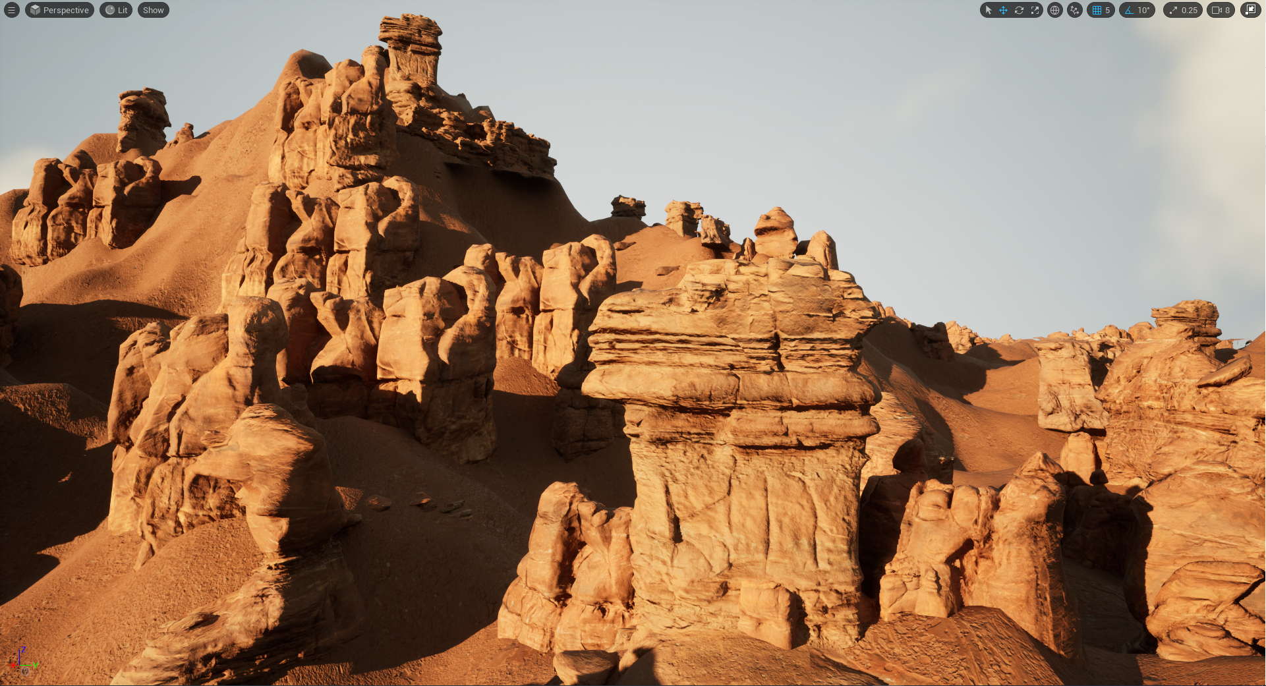

Assessment
Overall, it does not seem that great view distances or instance counts specifically cause Nanite to perform any better/worse than other case studies. The technology is designed specifically to prevent expensive sub-pixel geometry and it really shines in this particular test. Because the Nanite render pipeline does not work like traditional draw calls, the far distance and instance count does not seem to degree performance anywhere near the levels of the old render pipeline. This is great news for vistas/backgrounds in future projects.

Working with 163k instances in this case study appears to have the scene hit being CPU bound (on the draw thread) in both the flythrough and still camera. This is due to the GPU running so smoothly that the draw thread becomes the bottleneck. Even though Nanite has its own GPU pipeline it appears that HISM instances still get processed, at least partially, on the draw/render thread causing some minor holdup on occlusion. This isn’t concerning because it’s still a 5-6ms time but may be noteworthy. This trend does not hold up in different hardware configurations.

It appears that the instance cap changes based on hardware. On Hardware Configuration #1 the scene was able to generate ~465k instances but on the 5000RTX the scene generator would not exceed 100k instances.

On the 3090 RTX hardware configuration, the 1000-to-1 triangle ratio between the Nanite and traditional versions of the MegaScan’s holds up and actually performs 40% better. This has ranged from 10%-40% in different scenarios and is not consistent enough to be a “golden rule”. Still impressive that a 1000x triangle increase of source meshes also performs 39% better.

On the 5000 RTX hardware configuration, the same trend is present in the still shot, but not the flythrough. The Nanite scenario outperforms the Traditional setup by the same 39% in the still shot, but only 5.5% better in the flythrough.

The outcome of this case study, especially the hardware comparison, continues to reinforce the discovery that the triangle-to-performance ratio is highly dependent on both CPU and GPU power in hardware configurations. It should always be re-established per-hardware configuration.

Conclusion - The “Bottom Line”
Nanite is an extremely powerful rendering feature that does offer significant quality boost, when used correctly. It also carries a long list of restrictions, required best practices and flaws common of any new technology. It will be important to project Epic’s roadmap for Nanite moving into later versions of UE5 to gauge readiness and risk for ILMxLAB use.

In its current state, Nanite offers significant visual value for high-end projects when best practices are followed and gotchas are well-understood and planned for ahead of time. VR support is on the roadmap and we will follow closely with how that progresses.

Nanite is ready for use today, but our team’s must be prepared to work within its boundaries, supported features and gotchas/restrictions.

